DESKTOP PUBLISHING

WITH

ADOBE PAGEMAKER

TRAINING NOTES
WHAT IS PAGEMAKER?
PageMaker is a powerful software application used for desktop publishing and is available for both Windows and Macintosh users. The application allows you to manipulate features such as page size, text, graphics, and borders. PageMaker's strengths are in its ability to bring together text and images to make professional looking resumes, brochures, handouts, and newsletters.
This document will familiarize you with the PageMaker 6.5 environment and its components.
- The PageMaker Window
- Window Elements
- The Control Palette

The PageMaker Window
The PageMaker window contains many parts that work together to make creating a document easier.
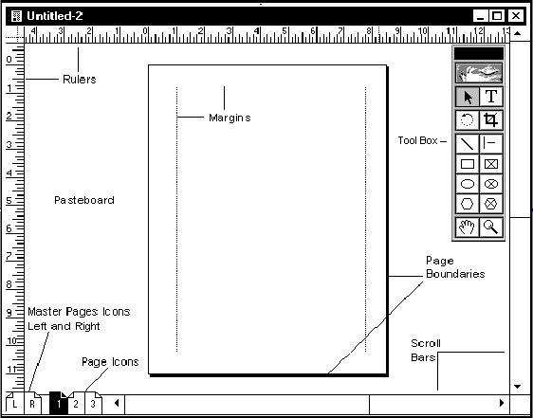

Window Elements
Understanding the elements you see in the PageMaker window is the first step to becoming comfortable with the application. The elements listed below are the ones you will use most often.

Title Bar
The title bar displays the document's name. If the document is unnamed, the name displayed in the title bar will be Untitled-1.
Rulers
Two rulers running vertically and horizontally along the screen can be set to measure in inches or picas (a pica is a unit of measurement used in typography, equal to 12 points, approximately 1/6 of an inch). If rulers are not visible on your screen or you need to change the measurement system of the rulers, see Working with Rulers & Guides.
Pasteboard
The pasteboard is the background behind the PageMaker document. It is useful for temporarily placing text and graphic elements when deciding where to place items, or when moving items between pages. Text and graphics on the pasteboard will not print.
Page Icons
The numbered page icons represent the pages of your document. The highlighted icon indicates which page(s) you are currently viewing. The L and R icons represent master pages. Items on master pages will appear on all pages of the document.
Margins
The dotted lines represent the page margins. Generally, all the text and graphics are placed within the page margins.
Page Boundaries
The page boundaries represent the edges of the paper. Any items outside or overlapping the page boundaries will not print.
Toolbox
PageMaker provides several tools that are used to accomplish various tasks. The most common tools are the Pointer and the Text tools. If the Toolbox is not visible, see Displaying the Toolbox.

Scroll Bars
Like Microsoft Word and other applications, PageMaker has scroll bars to help you move to various points on the current page(s). Scroll bars are not used to move between pages.
Resize Box
The Resize box (lower right corner) is used to change the size of the window. Click and drag it to change the window to the desired size.

Previous Size (refresh) Box
The Previous Size box (upper right corner) is used to refresh your screen display. This is especially useful when you have been making several editing changes or testing different font sizes and styles. Sometimes, bits of previous edits remain on the screen and using this option will clear it up. If you adjusted the size of the PageMaker window, this button will also return the window to its previous size.

The Control Palette
The Control Palette is used to manipulate both text blocks and graphics. There are three views within the Control Palette: Character, Paragraph, and Pointer. The view displayed depends on the tool that is selected. In each view, you can manipulate the text, paragraph, or object by adjusting the settings within the Control Palette.

To display the Control Palette:
- From the Window menu, select Show Control Palette
NOTE: If the Control Palette is already being displayed, Hide Control Palette will be appear under the Windows menu.
Character View
Displays font, type style, and type size when the Text tool is selected.
Paragraph View
Displays paragraph styles, alignment, indentation, and space before and after paragraphs when the Text tool is selected.
Placed Object View
Displays information of a placed graphic selected with the Pointer tool. You can scale, crop, and rotate the graphic using this Control Palette view.

Pointer View
Displays the x and y coordinates of the pointer as it moves around the PageMaker window.
In-Line Graphic View
Displays information about an image within the context of the text surrounding it. You can change the image's spacing from the text on either side and top and bottom. You can also crop the image to suit your needs.
The PageMaker Toolbox contains all of the tools you will use for creating and manipulating text and objects. It also contains two tools to help you view your publication. This document will familiarize you with the tools in the toolbox.
- Displaying the Toolbox
- PageMaker Tools
- Using the Zoom Tool

Displaying the Toolbox
If the Toolbox is not visible or if you have closed it and want to redisplay it, do the following:
- From the Window menu, select Show Tools
The Toolbox is displayed.

PageMaker Tools
This table describes the available tools and their function.
Icon | Function | Description
 | Version Window | Displays, when clicked, the version of PageMaker that is being used. To remove the Version Window, click inside this window.
 | Pointer | Selects lines, shapes, graphics, and text boxes. Selected items can be moved, resized, and have their attributes changed.
 | Text | Selects text or sets insertion point for adding text.
 | Rotate | Rotates text blocks and graphics to almost any angle.
 | Crop | Crops graphics (press and hold the [Shift] key to crop proportionally).
 | Line | Creates straight lines at almost any angle.
 | Constrained Line | Creates vertical, horizontal and 45-degree-angle lines.
 | Rectangle | Creates square and rectangle shapes.
 | Rectangle Text Box | Creates rectangular-shaped text boxes.
 | Ellipse | Creates circular and oval shapes.
 | Ellipse Text Box | Creates circular and oval-shaped text boxes.
 | Polygon | Creates basic polygons.
 | Polygon Text Box | Creates polygon-shaped text boxes.
 | Hand (Panning) | Allows the user to drag a page for optimal view.
 | Zoom | Magnifies or reduces the area of the page; useful for close placements or viewing of graphics.

Using the Zoom Tool
While using the Zoom tool, you can toggle between the magnification/reduction area of the page:

To enlarge the magnification of an area (zoom in):
- With the Zoom tool selected,
Windows: Click the mouse button
To reduce the magnification of an area (zoom out):
- With the Zoom tool selected,
Windows: Press [Ctrl] and click the mouse button
This document provides examples of the three most used dialog boxes in PageMaker.
- The Character Specifications Dialog Box
- The Paragraph Specifications Dialog Box
- The Fill & Stroke Dialog Box

The Character Specifications Dialog Box
The Character Specifications dialog box is used to define how the text appears. Many of these options are also available as individual choices from the Type menu and the Control Palette.

To open the Character Specifications dialog box:
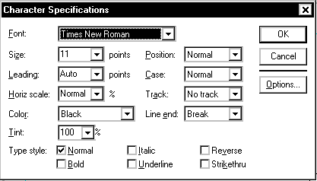
- From the Type menu, select Character...
The Character Specifications dialog box appears.

The Paragraph Specifications Dialog Box
The Paragraph Specifications dialog box is used to define paragraph characteristics including indents from the left and right margin and the first line of text. It also defines the amount of space that appears before and after the paragraph (can be used in place of pressing an extra return between paragraphs to add spacing), and special paragraph formatting including widow and orphan control and page breaks.
NOTE: Widows and orphans are words or short lines that become separated from the other lines in a paragraph at either the top (orphan) or bottom (window) of a page.

To open the Paragraph Specifications dialog box:
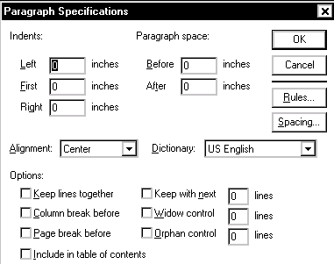
- From the Type menu, select Paragraph...
The Paragraph Specifications dialog box appears.

The Fill & Stroke Dialog Box
The Fill & Stroke dialog box is used to define the formatting characteristics of elements created with the PageMaker drawing tools. The Fill feature lets you specify patterns and the Stroke feature lets you specify line weight. In this dialog box, you can also control the color of the elements and how they will appear in respect to the background.

To open the Fill & Stroke dialog box:
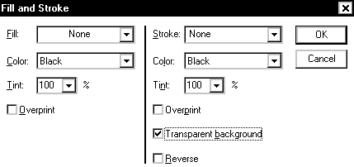
- From the Element menu, select Fill and Stroke...
The Fill and Stroke dialog box appears.
PageMaker provides the ruler and ruler guides to help you position or align text, objects or graphics with a great deal of precision. You can choose to display or hide the rulers and guides as your needs change. You can also choose to have objects which are placed close to a guide "snap to" the guide for easy and consistent alignment. This document gives instructions for the following:
- Displaying Rulers
- Changing Ruler Measurements
- Displaying Ruler Guides
- Placing Ruler Guides
- Locking Ruler Guides
- Removing Ruler Guides
- Using Snap To

Displaying Rulers
The horizontal and vertical rulers assist you in positioning elements on your page.
- From the View menu, select Show Rulers
NOTES:
The item that is available on the View menu will be determined by the choice currently in effect. If the rulers are showing, the menu choice will be Hide Rulers; if the rulers are hidden, the menu choice will be Show Rulers.
The ruler must be displayed in order to place and use guides.

Changing Ruler Measurements
PageMaker allows you to choose the system of measurement that will be used in the vertical and horizontal rulers. If you are using the Windows version, you can specify different systems of measurement for each ruler; however, the Macintosh version applies a measurement unit change to both the vertical and horizontal rulers.
Windows:
- From the File menu, select Preferences » General...
The Preferences dialog box appears.
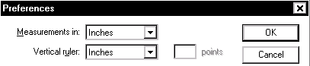
- From the Meaurements in pull-down list, select a measurement system
This measurement affects the horizontal ruler only.
- From the Vertical ruler pull-down list, select a measurement system
- Click OK

Displaying Ruler Guides
Displaying the ruler guides will help you position elements on your page. However, if you want to view the page with only the items that will print, you can "hide" the ruler guides.

To change the ruler guides display:
- Press [Ctrl] + [;]
This toggles between the Show Guides and Hide Guides option
OR
From the View menu, select Show/Hide Guides
NOTE: The item that is available on the View menu will be determined by the choice currently in effect. If the guides are showing, the menu choice will be Hide Guides; if the guides are hidden, the menu choice will be Show Guides.

Placing Ruler Guides
New ruler guides can be placed as you need them for alignment. You can place a guide regardless of what tool you currently have selected from the toolbox.
NOTE: The ruler from which you will be placing the guide must be displayed (see Displaying Rulers)
- To place a vertical guide, click and hold anywhere in the vertical ruler area
To place a horizontal guide, click and hold anywhere in the horizontal ruler area
- Drag the guide onto your page
A colored line appears.
- Release the mouse button

Moving Existing Guides
NOTE: You cannot move guides if the Lock Guides command is in effect (see Locking Ruler Guides).
- Select the Pointer tool
- Click and hold the guide
HINT: So that you do not select a text or graphic, click the guide in a margin or column gutter.
The Pointer turns into a double-headed arrow.
- To reposition a guide, drag the guide to its new location
To remove the guide, drag the guide into the ruler area

Locking Ruler Guides
To avoid inadvertently moving guides (e.g., column or margin), you can lock guides in place.
- From the View menu, select Lock Guides
This option is active if it is checked.

Unlocking Ruler Guides
- From the View menu, deselect Lock Guides
This option is inactive if it is not checked.

Removing All Ruler Guides
As your publication progresses, you may find that you have placed a large number of guides. In addition to dragging ruler guides off of your page (see Moving Existing Guides), you have the option to clear all guides at one time. This option will clear all placed guides; margin and column guides will remain.
NOTE: This option is not available if the Lock Guides command is in effect (see Unlocking Ruler Guides).
- Windows: From the View menu, select Clear Ruler Guides
Using Snap To
PageMaker offers two options for forcing alignment. You can make objects snap to ruler increments or to guides. This feature makes consistent alignment of multiple objects easy.

Snap to Rulers: Windows Only
Snap to Rulers pulls objects to the nearest ruler increment as you move them.
- From the View menu, select Snap to Rulers
The option is active if it is checked.

Snap to Guides
Snap to Guides will align objects to a guide when they are placed within three pixels of the guide. The guide does not have to rest on a ruler increment.
- From the View menu, select Snap to Guides
The option is active if it is checked.

Turning Off Snap To
- From the View menu, deselect the Snap to option you want to turn off
The option is inactive if it is not checked.
The CNS Online Help Collection is just one of the resources available for you. The following resources are also available to you as you work with PageMaker. Please note that some resources are only available for University of Wisconsin-Eau Claire faculty, staff, and students.
- Help Desks
- Workshops
- Additional Documentation

Help Desks
- CNS Help Desk
The CNS Help Desk provides support for UW-Eau Claire students, faculty and staff for supported software programs. You can call them at 836-5711, stop by their office at Old Library 1144, or send them email at helpdesk@uwec.edu. For more information, check out the CNS Help Desk website.
- General Access Computer Labs Help Desk
The Labs help desk provides support for students, faculty and staff working in the general access computer labs. You can call them at 836-5520 or stop by the desk in Old Library 1108.
- Housing Microcomputer Support
The Housing Help Desk provides support for the students working in the Housing computer labs or living in the residence halls. You can stop by their office, Towers 127, or call them at 855-4243. For more information checkout the Housing Microcomputer Support website.

Workshops
- BITS Workshops for UW-Eau Claire Students
BITS provides FREE workshops for UW-Eau Claire students on a variety of topics including Microsoft Word. For more information, see the BITS website.
- CITI & ITM Workshops for UW-Eau Claire Faculty and Staff
The CITI & ITM workshop series provides FREE workshops for UW-Eau Claire faculty and staff for supported software programs. For more information, please refer to the CITI & ITM Workshop website.

Additional Documentation

PageMaker's Online Help
As with many other programs, PageMaker provides extensive help right within the program.
- Open PageMaker
- Windows: From the Help menu, select Help Topics...
The Help dialog box appears.
- Select the Index tab
- In the text box, type a word or phrase for your topic
The scroll list below displays related topics.
- Select the topic that you would like information about
- Click DISPLAY
- Respond appropriately to the onscreen prompts
- When done, close the Help dialog box
PageMaker is designed to work best as a page layout program. It is excellent for documents with complex formatting and/or multiple pages, such as newsletters, resumes, reports, and, of course, handouts. The PageMaker window contains many parts that work together to make creating a document easy.
This document concentrates on the fundamentals of using PageMaker. Basics such as opening PageMaker, creating a file, saving, and printing will be addressed. This document will provide you with a foundation for building your PageMaker skills.
- Opening PageMaker
- Opening an Existing Document
- Creating a New Document
- About the Document Setup Dialog Box
- Saving a File Using Save As...
- Exiting PageMaker

Opening PageMaker
Opening PageMaker may vary from the instructions below depending on the computer you are working on.
Windows Users:
- From the Start menu, select Programs » Graphics » Adobe PageMaker 6.5

Opening an Existing PageMaker Document
Once you have closed a document, you can always reopen it at a later time and make changes or additions. With PageMaker open and running on your machine:
- From the File menu, select Open...
- Select the file you wish to edit
You may have to change drives and folders to find the file if it does not already appear in the list box.
- Click OPEN

Creating a New Document
- From the File menu, select New...
The Document Setup dialog box appears.
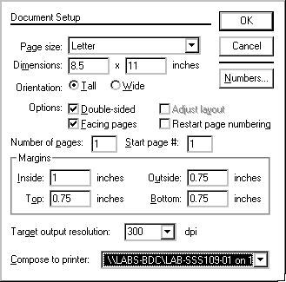
- Make the appropriate changes in the Document Setup dialog box
Refer to About the Document Setup Dialog Box for information on available options.
- When done, click OK
PageMaker will open a new document according to your Document Setup specifications.

About the Document Setup Dialog Box
The Document Setup dialog box allows you to determine what your document will look like.
Setting margins, page size, number of pages, and starting page
In PageMaker, the standard margin settings are: inside or left: 1.0, at outside or right: 0.75, top: 0.75, bottom: 0.75. You can adjust them to fit your needs.

Setting page dimensions
Standard page dimensions are 8.5" x "11" for letter size paper. Change the dimension in the selected box by typing in a new number. Select a different box by pressing the [Tab] key or double clicking on the box.

Determining page orientation
The page may be tall or wide in orientation.

Adjusting the number of pages
Change the number of pages by typing the appropriate number in the Number of pages text box.

Other Options
Pages can be set up as single, double-sided or facing. (Pages cannot be facing unless they are double-sided.) For single-sided pages there should be no options selected. The following descriptions should help with your decision making:
Single-sided
Pages show only one page at a time on the screen and only one master page is created.

Double-sided
Pages also show only one page at a time on the screen. However, two master pages are created. This option is appropriate for publications that will be printed on both sides of a page.

Facing
Pages display two pages at a time on the screen (except page one, which is displayed alone). This selection is appropriate if you are setting up a magazine or booklet, because the pages are set up to face each other, just as they would in a book.

Saving a File Using Save As...
PageMaker allows you to save your document as a PM publication, a template, or it will save a copy of your PM 6.5 document in a PM 6.0 format. Saving a document in an earlier version allows you to share files with others who do not have the same version of PageMaker as you.
Saving for the First Time
Save As allows you to name the file. Do not panic if you choose the Save option instead of Save As the first time you save your document. PageMaker will always generate a Save As dialog box if you are attempting to save an untitled document.

Saving under a New Name
If you want a copy of your file saved with a new name use Save As to rename the file. The original-titled document will remain as it was after the last save. The new file name will appear in the title bar and any additional saves will be to the new file.

Saving as a Template
If you want to save your formatting for use in subsequent documents, use Save As to save the file as a template. For more information, see Creating a Template.

Compacting a Large File
If a large PageMaker document is taking up too much disk space, choose the Save As option but do not change the document’s name or location. PageMaker will ask if you want to replace the existing file with the same name. Click YES. The file will essentially reorganize itself on the disk and take up less disk space.

Using Save As...
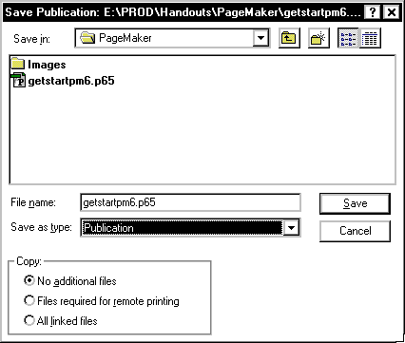
Use the Save As option to save a file for the first time, to save a file under a new name, or to compact a file.
- From the File menu, select Save As…
The Save As dialog box will prompt you to name or rename your file.
- Check to see that the file is being saved in the proper location and adjust its location if necessary
- Type the file name
- Windows: To save as a template or as a different version, from the Save as type pull-down listing, select the file type
When you are finished, click OK

Using Save
Use the Save option to save additional changes to a file that has been previously saved.
- From the File menu, select Save
PageMaker will save changes made since the last save. A watch or an hour glass will appear on the screen indicating a Save is in progress. Once the file has been saved, the last tool you were working with will appear on the screen and you can continue working.

Exiting PageMaker
Remember to save your document before exiting! If you want to work on another PageMaker document, simply close the current document.

To Remain in PageMaker after Closing
- From the File menu, select Close
If you forgot to save your document, PageMaker will ask “Save changes before closing?”
- To save, click YES
To close without saving, click NO
To abort the close request and return to the document, click CANCEL
After closing you can create a new file or open an existing PageMaker file.

To Exit the Document and the PageMaker Application
- From the File menu, select Quit
Many of the concepts and techniques that you know from working with a word processor will carry over to PageMaker. One key difference is that you must select the Text tool before you begin to edit. The Text tool looks like this:
When making formatting adjustments to text (e.g., font or size), you will be working with options from the Type menu.
- Typing Text
- Placing an External Text File into Your Document
- Using the Text Tool
- Selecting Text
- Changing Type Specifications
- Cutting, Copying, and Pasting Text

Typing Text
Typing large volumes of text in PageMaker is not advised. But using PageMaker to type headlines, titles, captions, headers and footers (type which is usually set off with a different style or placement) is easy.
If you need to type or edit a large amount of text, you may want to use the Story Editor or your word processor. For more information about editing text in PageMaker see Using Story Editor.
- From the Toolbox, select the Text tool
- Move the tool across the screen
It looks like a curved I and is referred to as an I-beam.
- Place the I-beam where text should begin and click to create an insertion point
NOTE: Unless text already exists, the insertion point will position itself at the current default alignment.
- Type the text

Placing an External Text File into Your Document
Text files from PageMaker-compatible word processing programs such as Microsoft Word and WordPerfect can be placed into a PageMaker document. Text files with little or no formatting generally work best. After placing the text into PageMaker you can edit, format and manipulate it using the same methods as you would for text typed directly into PageMaker.

Flowing Text
PageMaker offers two methods of placing text files into your publication.
Autoflow
Autoflow allows you to place text and have it flow automatically into each column on the page and onto subsequent pages (adding them if necessary). To activate Autoflow from the Layout menu, select Autoflow. When Autoflow is active, your cursor will appear as .
Manual Flow
Manual text flow requires you to change to each page on which you want the text to appear. If you choose to use the Manual text flow option your cursor will change to .

Placing an External Text File
This option will allow you to alter and edit the text after it has been placed in PageMaker, as it will come in as a story.

Option 1: Place file
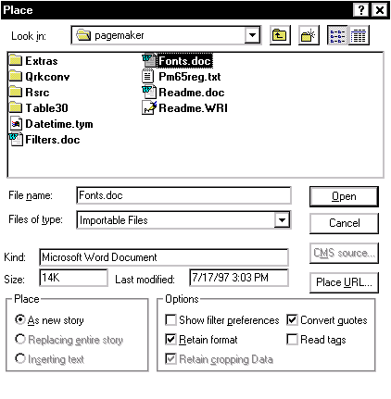
- From the File menu, select Place...
The Place dialog box appears.
- Select the file you wish to place
- Click OPEN or OK
Your cursor turns into one of the place text icons
- Place the icon where you want the file inserted
- Click to flow text

Option 2: Insert Object
NOTES:
The file comes into PageMaker as an object, not a story, therefore there will be no flowing of text. After the object is inserted in your PageMaker document, since it is not a story, you will not be able to make edits by changing the text.
- From the Edit menu, select Insert Object...
The Insert Object dialog box appears.
- Windows: Select Create From File...
Select the file you want to insert
- Click OK
- Windows: Click OK
The object appears in your document.
- Click and drag the object to move it to the desired location
- Use the handles to resize the object as appropriate

Using the Text Tool
To edit or format text, you must first select the range of characters you want to effect and you use the Text tool to accomplish this. To deselect text, click another insertion point, or select any tool in the toolbox. Using the Text tool you can:
- Double-click to select a word.
- Triple-click to select an entire paragraph.
- Drag the I-beam to select a range of text.

Editing Text
If you make a mistake while typing, you can always go back and fix it, just as in a word processing application. For more information about editing text in PageMaker see Using Story Editor. To edit text:
- From the Toolbox, select the Text tool
- Create an insertion point by clicking the I-beam within the text you wish to edit
- Use the mouse or the arrow keys on the keyboard if necessary to move to the correct location
- Make the appropriate changes
• To insert text, simply type and text will appear at the insertion point
• To delete text to the right of the insertion point, press the [Delete] key
Existing text in the same text block will automatically reposition to adjust to the new or deleted text.
You can also delete or type over large sections of text by first selecting the text and then pressing [Delete] or typing new text. See Selecting Text.

Selecting Text
You will select text when you want to change its type specifications, cut or copy it, or delete it. Use the Text tool to select text for editing.
HINT: If you have problems selecting the first character at the edge of a text block, start with the last character and drag to the first character.

Selecting a Portion of Text
- From the Toolbox, select the Text tool
- Place the I-beam at the beginning of the text you wish to select
- Click and drag to select the appropriate text

Selecting an Entire Text Block
A block of text is text that is connected, such as text that was placed from a single word processing file or text that was typed in PageMaker from a single insertion point. A text block can consist of one letter or of many pages.

To select an entire text block:
- Using the Text tool, place the insertion point anywhere in the text block
- From the Edit menu, choose Select All

Options with Selected Text
- To delete the selected text, press the [Delete] key.
OR
Begin typing. The selected text will be replaced by the new text that you type.
- To change type style, from the Type menu select the appropriate options.
For more information see Changing Type Specifications.
- To move or duplicate the text, from the Edit menu, use the Cut, Copy and Paste.

Changing Type Specifications

To change the type specifications of existing type:
- Select the text
- From the Type menu, select the appropriate option
Many of these options have a submenu indicated by the arrow to the right of the menu option name.
- From the submenu, select the appropriate option
A checkmark will now appear by the option you selected, and the selected text on the screen will change to reflect your choice. (e.g., If you selected Bold under Type Style, the selected text will become bold.)
- Click outside of the selected text area to deselect text

To choose type specifications before you type the text:
- Using the Text tool, set the insertion point where the text will begin
- From the Type menu, make the appropriate selections
- Type the text (do not reset the insertion point)
The new text will have the characteristics that you selected in step 2.
HINT: If you change the insertion point before you begin typing, text will revert back to previous type settings.

Cutting, Copying, and Pasting Text
Cut and copied items are placed on the Clipboard (a temporary storage location). The most recent cut or copy remains on the Clipboard and is inserted into the document when the Paste command is selected. To cut, copy or clear a portion of text, from a single letter to an entire text block, select the Text tool and select the text you wish to cut or copy.
WARNING: The computer will retain only one cut or copy at a time. If you select Cut and then select another item or items and select Cut or Copy, the first item or group of items will be replaced on the Clipboard by the second group.

Deleting Selected Text
- From the Edit menu, select Clear
OR
Press the [Delete] key
HINT: This text does not go on the Clipboard.

Retrieving Cleared or Deleted Text
You can retrieve deleted text that has not been save to the Clipboard but you must do it immediately after it was cleared.
- From the Edit menu, select Undo Edit

Moving Selected Text
- From the Edit menu, select Cut
- Place the insertion point where you want the text to appear
- From the Edit menu, select Paste

Copying Selected Text
- From the Edit menu, select Copy
- Place the insertion point where you want the text to appear
- From the Edit menu, select Paste
When you are working with PageMaker, you will have the flexibility to define your text area. To determine the boundaries and placement of the text, you will be using the Pointer tool.
When you are working with the Pointer tool, you will be working with the text as a block of information. This block can be resized, moved, deleted, copied, and more.
The Pointer tool looks like this
- Text Blocks
- Selecting Text Blocks
- Manipulating Text Blocks
- Working with Columns of Text

Text Blocks
A text block is a portion of a story. A story is text that PageMaker recognizes as a single unit. A story can be one letter or several pages of text and can be contained in a single text block or threaded through many different ones.
In PageMaker, several stories may appear on the same publication page and continue elsewhere in the publication, but each story is a separate unit. When you add or remove text in a story or adjust the size or shape of text blocks that contain part of a threaded story, the text flows through existing text blocks until it gets to the end of the story. If you add text to a threaded story, you may need to adjust the size of the last text block or create a new text block so that all of the text is visible.

Text Block Indicators
The beginning of a text block is indicated by an open windowshade handle at the top of the text block. The end of the text block is indicated by an open windowshade handle at the bottom of the text block. A plus sign (+) in the windowshade handle indicates there is more text before or after the current portion of the text block. A red triangle at the bottom of the windowshade handle indicates that there is additional text in the text block but it is not showing anywhere in the document. The square boxes on the edges of the windowshade are handles that can be used to resize or reshape the text block.
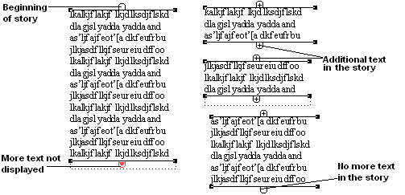

Selecting Text Blocks
When selecting and working with text blocks, you must select the Pointer tool.

Selecting a Single Text Block
- From the Toolbox, select the Pointer tool
- Click in the text block
This will select only the current portion of the block.

Selecting Multiple Text Blocks
- From the Toolbox, select the Pointer tool
- Click in the text block
- Hold down the [Shift] key and click each text block

Selecting All Items on a Page
- From the Toolbox, select the Pointer tool
- From the Edit menu, select Select All
Now the selected elements can be moved, copied, or deleted as a group.
NOTE: If the story takes up more than one page, this will select only the portion that is on the current page.

Manipulating Text Blocks
Windowshade handles can be used to manipulate a text block’s size, shape, and placement on the page. Besides the functions listed here, text bracketed by windowshade handles can also be cut or copied.

Placing Additional Text
If a red triangle appears in the bottom windowshade handle of a column of text, the computer is indicating that there is additional text that needs to be placed. To place the text:
- Position the tip of the Pointer tool at the bottom tip of the triangle and click once
If you positioned the pointer correctly, the pointer should turn into a text icon.
- Position the text flow icon where the text should continue
- To place the text, click once

Moving Text
- Click the text block anywhere except in a handle and hold the mouse button down until a four-sided arrow appears
- Still holding the mouse button, drag the mouse to move the text
- Release the mouse button when the text is positioned correctly

Deleting Text
- Using the Pointer tool, select the text block you wish to delete
- Press the [Delete] key
Only the selected text block will be deleted.

Working with Columns of Text

Shortening or Lengthening a Column of Text
As you adjust the length of columns, no text is being removed or lost. Instead, the layout space is being shortened or lengthened in that particular column. Drag the windowshade handles up or down to shorten or lengthen text blocks.
- Position the tip of the pointer on the windowshade handle
- Click and hold the mouse button
The pointer turns into a double-headed arrow.
- Drag the handle up or down to shorten or lengthen the text column
- Release the button and the text will reposition itself

Extending Text across Column Boundaries
On some occasions, text needs to extended across two or more columns. For example, an article may be placed on a three-column page, but the title needs to extend across all three columns.

To extend a text block across columns:
- With the Pointer tool, select the text block
Notice the handles at the ends of the brackets.
- Click one of the handles and hold until the Pointer tool turns into a double-headed arrow
- Drag the arrow across columns until the block reaches its preferred size and release the mouse button
PageMaker offers options for creating special effects with text. A drop cap can be used to distinguish the beginning of a paragraph. Reverse text can be used to emphasize text such as a heading or label.
- Using Drop Caps
- Using Reverse Text

Using Drop Caps
You can quickly and easily enhance the appearance of a document by adding interesting design elements to text such as drop caps. A drop cap is a large initial character, often used at the beginning of a paragraph. In PageMaker, you can define how many lines of text will wrap around the drop cap. PageMaker automatically inserts the necessary information to create the drop cap.
If you edit the lines around a drop cap, you may have to delete the tabs and line breaks PageMaker inserted to create the drop cap and insert new ones yourself. Because of this, it is better to create your drop cap after all editing is completed.
Note: You cannot create drop caps in paragraphs with Top of Caps leading (see Working with Leading) or when the first character is a graphic, tab, space, bullet, or a similar character.

Creating Drop Caps
- From the Toolbox, select the Text tool
- Click the insertion point anywhere in the paragraph you want to begin with a drop cap
- From the Utilities menu, select Plug-ins » Drop cap...
The Drop cap dialog box opens.
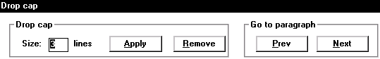
- In the Size text box, specify the number of lines to wrap around the drop cap
- OPTIONAL: To view the drop cap without leaving the dialog box, click APPLY
- OPTIONAL: To move to other paragraphs and continue adding drop caps, click PREV or NEXT
- When you are finished, click OK

Removing Drop Caps
- From the Toolbox, select the Text tool
- Select the paragraph(s) with drop caps you want to remove
- From the Utilities menu, select Plug-ins » Drop cap...
The Drop cap dialog box opens.
- Click REMOVE
- Click OK

Editing Drop Cap Characters
NOTE: It may be easier to remove the drop cap and reapply than to edit.
- With the Text tool, highlight the drop cap character
Only the top-half of the character may be highlighted.
HINT: To view the entire drop cap character click the PREVIOUS SIZE (Refresh) button in the upper right corner of the window.
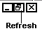
- Type a new character
- Select the rest of the word and type the new characters

Using Reverse Text
Instead of the usual black text on white background, you might want to emphasize a portion of your document by using reverse text (e.g., white text on black). The process of creating reverse text is a simple one, requiring two main steps: creating the black background and changing the type style to reverse. New users of reverse text often run into problems because they forget to make the background black first, resulting in unreadable white text on a white background. If you create the background and then place the reverse text on top of it, you will find the process easier.

Creating a Block of Reverse Text
- From the Toolbox, select the Drawing tool for the shape of the background you want to create (e.g., circle, rectangle, polygon)
- Draw the background shape
- With the shape still selected, from the Element menu, select Fill » Solid.
NOTE: You can place reverse text over a background that is less than 100 percent colored, but you will have to evaluate the readability of the text and adjust the shading appropriately.
- To insert text, from the Toolbox, select the Text tool
- Draw a text box on top of the background shape you have created
- From the Type menu, select Type Style » Reverse
- Begin typing your text
Your text should appear white over the background.
NOTE: You can change existing text to reverse text by creating a background, moving the text over the background, selecting the text, and changing it to reverse.
To edit text in a format that looks and behaves more like a word processor use the Story Editor. The Story Editor displays all the text in a particular story at the same size in block format for easy editing, even if the story spans several pages in your document. A scroll bar to the right of the text allows you to scroll through the text block. The Spell Checker and the Find and Change commands are available only within the Story Editor. Because the Story Editor does not display all of the text enhancements, editing and typing text here is faster than in the layout mode.
- Opening the Story Editor
- Using the Find and Change Feature
- Using Spell Check
- Exiting the Story Editor

Opening the Story Editor
Menu Option:
- Click on the block of text you want to edit
- From the Edit menu, select Edit Story
The text of the entire story will now appear in the Story Editor.
Mouse Option:
- To access the Story Editor with the Pointer tool, triple-click in a text block

Using the Find and Change Feature
PageMaker allows you to search stories in the Story Editor for specific words or phrases and to replace all or some of the occurrences with other words or phrases. In order to simply find an occurrence, use the Find feature. In order to change some or all of the occurrences to something else, use the Change feature.

Using Find
Make sure you are in the Story Editor. The Spelling, Find, Find Next, and Change commands are available only in Story Editor.
The Find feature allows you multiple choices in searching your document and story. The Search story function allows you to work with:
Selected text | The Find feature will search only the text you have selected.
Current story | The Find feature will only search the current open story.
All stories | The Find feature will search all stories.
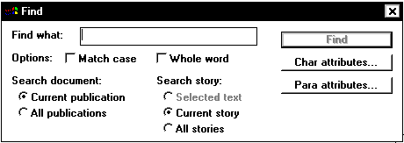
- From the Utilities menu, select Find...
The Find dialog box will appear on the screen.
- In the Find What box, type the word or phrase to look for
- Click FIND
- To find subsequent occurrences of the word or phrase, from the Utilities menu, click FIND NEXT
When no more occurrences exist, the Search Complete dialog box will appear.
- Click OK
- To find another word or phrase, repeat steps 2-5
- When finished, close the Find dialog box

Using Change
Make sure you are in the Story Editor.
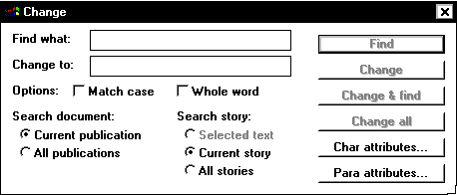
- From the Utilities menu, select Change...
The Change dialog box will appear on the screen.
- In the Find What text box type the word or phrase to find
- In the Change to box type the replacement word or phrase
- To find the first occurrence of the word or phrase, click the FIND button
OR
To find and change all occurrences of the word or phrase, click CHANGE ALL
(If you selected Change All, skip to step 7.)
WARNING: Use Change All with caution. You may change words you did not mean to change. If you do use Change All, select the Whole Word option and review the document to make sure all replacements make sense.
- If you selected Find in step 4, you now have several options
• To change the word, click CHANGE
• To ignore the word, click IGNORE
• To find the next word, click FIND NEXT
• To change the word and find the next one, click CHANGE AND FIND
• To change all occurrences of the word, click CHANGE ALL
- When the Search Complete dialog box appears, click OK
- Type in a new word or phrase to find and change
OR
Click CLOSE

Using Spell Check
Spelling can only be checked in the Story Editor. The Spell Check feature of PageMaker checks your text against the computer’s dictionary. If the computer does not recognize a word, the top left corner of the dialog box will read “Unknown word” followed by the unrecognized word. You have the option of ignoring the word, replacing the word with a new spelling, or adding the word to the computer’s dictionary.
If you want the word to remain in the document spelled as it is, click IGNORE. For example, the computer will probably not recognize your first and last name, but you do not want their spelling changed. The word will be added to a temporary dictionary that is active until you exit PageMaker.
WARNING: If you are working in a general access computer lab, DO NOT add words to the dictionary; simply click IGNORE.

Check Spelling
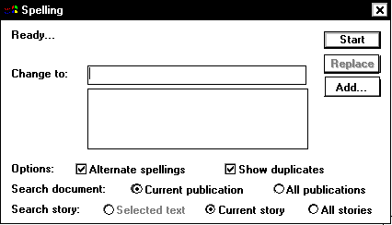
- From the Utilities menu, select Spelling...
The Spelling dialog box will appear on the screen.
- OPTIONAL: To check all stories in your document, select the All Stories option.
- Click START
- If all the words are recognized by the computer’s dictionary, No Spelling Errors Detected will appear in the upper left of the dialog box
If this happens continue with step 6.
  - If a word is not recognized by the computer’s dictionary Unknown Word will appear in the upper left of the dialog box. In the Change To box, delete it and type a new spelling. If this happens, continue with step 5.
  - If the word is mispelled and the computer’s dictionary recognizes it, the word will appear in the Change To box. In the text area below the Change To box, the computer will list possible spellings for the mispelled word. Select the correct choice, and move on to step 5.
- Click REPLACE
When the spell check is done, the phrase "Spelling Check Complete" will appear.
- Click CLOSE

Exiting the Story Editor
- From the Edit menu, select Edit Layout
OR
From the Story menu, select Close Story
OR
Click the CLOSE box
This information will help you print your PageMaker document.
- Printing a Basic/Standard Document
- About the Print Dialog Box
- Printing a Non-letter Size Document

Printing a Basic/Standard Document
Before printing, it is best to first save your document in case problems occur.
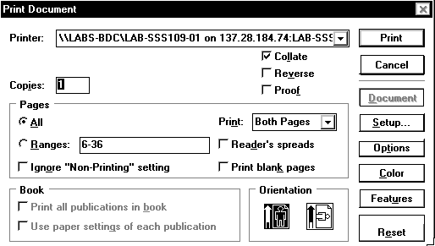
- From the File menu, select Print...
The Print dialog box will appear.
- From the Printer pull-down listing, choose the desired printer
- Make the necessary changes to the Print dialog box
See About the Print Dialog Box for more information.
HINT: To view more print options, click OPTIONS
- To begin printing, click PRINT

About the Print Dialog Box
Printer
Check to see that the printer name matches the printer that you want to send your printout to. If necessary you will need to change printers. You can change printers in the Print dialog box, or you can set a default printer that will automatically be used every time you print.

To set a default printer:
- From the Start menu, select Settings » Printers
- From the submenu, select the printer you wish to set as your default printer
The Printer dialog box appears.
- From the Printer menu, select Set As Default
The selected printer is now the default printer, and a check appears next to Set as Default on the Printer menu.
- From the Printer menu, select Close
Number of Copies
To print more than one copy of the document, make sure that the box to the right of Copies is highlighted (if not press the [Tab] key until it is) and type the number of copies you want.

Pages
- To print every page of the document, under Pages, select All.
- To print only part of the document, select Ranges.
In the textbox to the right, type the page number of the first page to print, followed by a hyphen and the last page to be printed.
- To print nonconsecutive pages, type in the pages you wish to print and separate them with commas.
Example: to print pages 1-14 of a document, type: 1-14
To print pages 1, 5, and 7-9 type: 1,5,7-9

Orientation
Confirm that the paper orientation matches how you intend your document to be printed. Your options are tall (portrait) or wide (landscape).

Printing a Non-letter Size Document
When you want to print a document that is a different size than the standard letter size, you must first specify the size of the document and then configure the print size before you print your document.

Printing a Non-letter Size Document: Document Setup
Use these steps to configure your document size. If you have already configured your document size, then you can skip to the next section Printing a Non-letter Size Document: Print Setup.
- From the File menu, select Document Setup...
The Document Setup dialog box appears.
- From the Page size pull-down listing, select the desired paper size
- Click OK

Printing a Non-letter Size Document: Print Setup
- From the File menu, select Print...
The Print dialog box appears.
- Click SETUP...
The Printer dialog box appears.
- Select the Paper tab
- From the Size is pull-down listing, select the desired paper size
NOTE: The size of the document must match the size paper you select here. There are a number of selections for each paper size, so make sure you choose the same size for both the document setup and the print setup before attempting to print your document.
- Select the Basics tab
- From the Orientation section, select the desired orientation of the paper
- Click OK
- Click PRINT
This information will help you print your PageMaker document.
- Selecting a Printer
- Printing a Document
- About the Print Dialog Box

Selecting a Printer

Using Chooser
You must use Chooser to select the printer for where you are working.
- From the Apple menu, select Chooser
The Chooser dialog box appears.
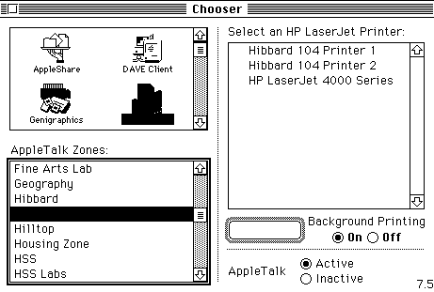
- From the top left text box, select a printer icon
- From AppleTalk Zones, select the appropriate choice for where you are working
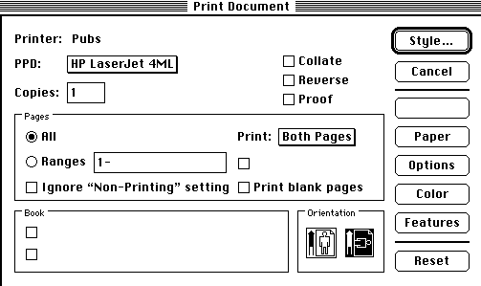
- From the listing on the right, select a printer
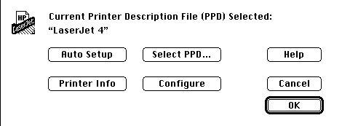
- Click SETUP
The Setup dialog box appears.
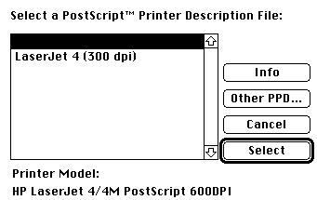
- Click AUTO SETUP
The Printer Description dialog box appears.
- Choose the printer you wish to use
- Click SELECT

Printing a Document
Before printing, it is best to first save your document in case problems occur.
- From the File menu, select Save
- From the File menu, select Print...
The Print Document dialog box will appear.
- Make the necessary changes to the Print dialog box
See About the Print Dialog Box for more information.
HINT: To view more print options, click OPTIONS
- To begin printing, click PRINT

About the Print Dialog Box
Printer
Check to see that the printer name matches the printer that you want to send your printout to. If necessary you will need to change printers using the Chooser function, or set a default printer that will automatically be used every time you print.

To set a default printer:
- From the Apple menu select Chooser...
The Chooser dialog box will appear.
- From the AppleTalk Zones listing, select the printer you are connected to
- To choose a printer type, from printer icon listing, select the appropriate printer icon
The selected printer is now the default printer.
Number of Copies
To print more than one copy of the document, make sure that the box to the right of Copies is highlighted (if not press the [Tab] key until it is) and type the number of copies you want.

Pages
- To print every page of the document, under Pages, select All.
- To print only part of the document, select Ranges.
In the textbox to the right, type the page number of the first page to print, followed by a hyphen and the last page to be printed.
- To print nonconsecutive pages, type in the pages you wish to print and separate them with commas.
Example: to print pages 1-14 of a document, type: 1-14
To print pages 1, 5, and 7-9 type: 1,5,7-9

Orientation
Confirm that the paper orientation matches how you intend your document to be printed. Your options are tall (portrait) or wide (landscape).
Leading is the vertical space between lines of type and is measured in points. Like letter and word spacing, the right amount of leading makes text easier to read. You can specify the leading value yourself or let PageMaker determine it automatically.
- Adjusting the Space between Lines of Text
- Positioning Text within its Leading
- Setting Autoleading Values for a Selected Paragraph(s)
- Setting Spacing for a Selected Paragraph(s)

Adjusting the Space between Lines of Text
Leading settings have two parts:
Leading Value
Measures the entire vertical space allotted for a line of text.
Leading Method
Defines where the text is placed.

Selecting a Leading Value
PageMaker automatically inserts leading as you enter text into your document; however, there may be times when you want to control the value of the leading. What constitutes reasonable leading varies with the requirements of each document and each font used.
NOTE: You can apply more than one leading value within the same paragraph. However, if different leading values occur within a single line of text, PageMaker uses the largest leading value for the entire line.

To choose a leading value for selected text
- Select the text to which you want to apply a leading value
- From the Type menu, select Leading
- From the Leading submenu, select a value
HINTS:
To restore the default leading value, select Auto
To set a custom leading value, select Other...
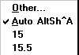

Positioning Text within its Leading
There are three methods you can use to position a line of text within its leading (vertical space). You can select Proportional, Top of Caps, or Baseline. The leading method is applied uniformly to all characters in a paragraph, even if the leading amounts differ.
The following graphic represents examples of the three leading methods.
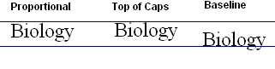
Proportional | positions the baseline of a line of text two-thirds of the way down from the top of the vertical space. This is the default leading method.
Top of Caps | positions the text, based on the highest point on any character of the largest font in the line, at the top of the vertical space.
Baseline | aligns the text at the bottom of the vertical space. Descenders will appear beneath the baseline.
To select a leading method:
- Select one or more paragraphs
- From the Type menu, select Paragraph...
The Paragraph Specifications dialog box appears.
- Click SPACING...
- In the Leading method section, select the method desired
- Click OK

Setting Autoleading Values for a Selected Paragraph(s)
PageMaker's default leading is set at 120% of the font size when you select Auto for the leading value. You can change that percentage for one or all paragraphs.
- Select one or more paragraphs
- From the Type menu, select Paragraph...
The Paragraph Specification dialog box appears.
- Click SPACING...
The Spacing Attributes dialog box appears.
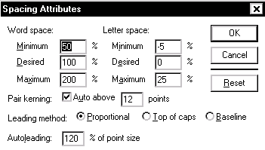
- In the Autoleading text box, type the percentage you wish to apply to the paragraph
- Click OK
- In the Paragraph Specifications dialog box, click OK

Setting Spacing for a Selected Paragraph(s)
There may be times when you need a paragraph set off so it will draw attention to itself. In many cases you do not need to use fancy and distracting graphics or borders when added spacing will do the trick.
- Select one or more paragraphs
- From the Type menu, select Paragraph...
The Paragraph Specification dialog box appears.
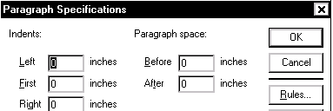
- In the Paragraph space text boxes, type the amount of space you want applied before and after the paragraph
- When finished, click OK
Tracking and kerning are two PageMaker options for controlling the space between characters. Kerning is helpful for fine-tuning the space between individual characters whereas tracking is useful for larger blocks of text. By adjusting the track first, you may have to do less kerning. Spacing allows you to adjust the space between individual characters, words, and lines.
- Working with Tracking
- Working with Kerning
- Using Spacing

Working with Tracking
Tracking refers to the space between individual characters only. Tracking adjusts the relative space between characters so that it gets tighter at larger sizes and looser at smaller sizes. PageMaker offers several tracking options from Very Loose to Very Tight. You can adjust the track for an entire paragraph, a single line, or a few characters. Here is an example of the different types of tracking opposed to normal text:
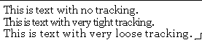

Adjusting Tracking
- Select the text that you want to track
- From the Type menu, select Expert Tracking
- From the submenu, select the desired choice

Editing a track:
- From the Type menu, select Expert Tracking » Edit Tracks...
The Edit tracks window appears.
- From the Track pull-down list, select the track you wish to modify
- In the graph section, use the mouse to move the handles as desired
NOTE: Adjusting a handle to a higher point tightens the track.
- OPTIONAL: Use the RESET button to restore the default settings
- OPTIONAL: To add or delete a track handle:
Windows: While holding the [Alt] key, click on the track line where you would like to add/delete the handle
- Click SAVE
- Click OK

Returning to the normal track:
- Select the text that you want to track
- From the Type menu, select Expert Tracking
- From the submenu, select Normal

Working with Kerning
Kerning usually refers only to the space between pairs of characters. Desktop publishing programs use linear calculations to determine character spacing. Sometimes this results in too much spacing at large point sizes and too little at small ones. Kerning adjustments are exactly proportional to the characters. PageMaker allows you to kern text manually, automatically, or both between two characters or, if necessary, over a range of text. Here is an example of what kerned characters look like opposed to regular characters:
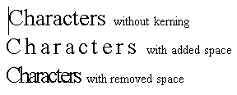

Automatic Kerning
- Select the text you want to kern
NOTE: Kerning affects the space after a character. So, if you want to change the kerning of a word, but not the width of space after the word, select all but the last character of the word.
- From the Type menu, select Paragraph...
- In the Paragraph Specifications dialog box, click SPACING...
The Spacing Attributes dialog box appears.
- From the Spacing Attributes dialog box, select Pair kerning
The selection will be checked.
- In the Auto Above text box, type the font size to which you want to apply auto-kerning
- To return to the Paragraph Specifications dialog box, click OK
- To return to your document, click OK

Kerning with the Control Palette
- Place your insertion point between the two characters
OR
Select the text you want to kern
NOTE: Kerning affects the space after a character. So, if you want to change the kerning of a word, but not the width of space after the word, select all but the last character of the word.
- To add or delete space between the characters, press the appropriate nudge button
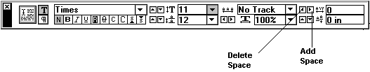

Using Spacing
Spacing refers to the space between individual characters, words, and lines. Type is defined by its particular spacing. Adjusting the spacing between characters and words can improve legibility. Typefaces are designed with the correct amount of spacing to make it look its best, but special situations can result in the type looking too crowded or too loose.
Tight spacing lets you place more text on the page, but can make it difficult to distinguish words from each other. Loose spacing fills up a page with a small amount of text, but becomes harder to read as the words begin to look disconnected.

To adjusting spacing
- Select the text that needs the spacing adjusted
- From the Type menu, select Paragraph...
The Paragraph Specification dialog box appears.
- In the Paragraph dialog box, click SPACING...
The Spacing Attributes dialog box appears.
- In the Word space: column, make the desired adjustments
- In the Letter space: column, make the desired adjustments
- Click OK
- In the Paragraph Specifications dialog box, click OK
Once you have begun working on a document, you may decide that the number of pages you originally assigned to the document is not enough or perhaps too many. You can adjust the number of pages by inserting or removing them.
- Inserting Pages
- Removing Pages

Inserting Pages
To insert additional pages into your document:
- Place your cursor in the page that you want the additional pages to precede or follow
- From the Layout menu, select Insert Pages...
The Insert Pages dialog box appears.
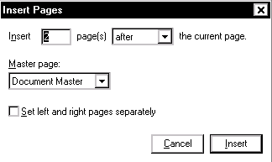
- In the Insert Pages dialog box, type the number of pages you want to insert and indicate whether you want them to appear before or after the current page
- Click INSERT

Removing Pages
To remove extra pages from your document:
- From the Layout menu, select Remove Pages...
The Remove Pages dialog box appears.
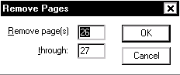
- Type the range for the page numbers you want to remove
For example, if you want to remove page 7 only, you would fill in:
Remove page 7 through 7
- Click OK
- To confirm that you want to remove those pages, click OK
Working with newsletters and brochures often requires the use of columns (see Sample Dimensions for a Brochure). While you can create columns manually by setting your text block's width, this process can be made easier by creating columns. As you create columns with PageMaker, a set of guides (like the page margins) are added to the page.
When you first create your document, its default is one column per page. PageMaker provides the option of creating up to 20 columns on a single page. Between each column will be a “gutter.” The gutter adds some white space between each column so text will not appear on top of the next column. If you are using the columns for a brochure, these gutters should be larger to add space for folding.
NOTE: If you want to set columns for all pages of your document, set them on the master pages (see Using Master Pages).
- Creating Columns
- Adjusting Column Placement
- Locking Column Guides

Creating Columns
- Move to the page on which you want the columns to appear (this can be one of the master pages if you want them to appear on all the left or right pages)
- From the Layout menu, select Column Guides...
The Column Guides dialog box appears.
- In the Column Guides dialog box, type the number of columns that you want for the page
HINT: If you have facing pages, you can set different columns for each page by clicking Set left and right pages separately.
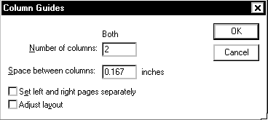
- OPTIONAL: Adjust the Space between columns:
- Click OK

Adjusting Column Placement
If you need to adjust the placement of the column guides, which appear as light blue dividers, use your mouse to drag the column guide to the proper position.
- From the Toolbox, select the Pointer tool
- Click the column guide
Do not release the mouse button.
NOTE: Click the guide over an empty space to make sure you do not include text or graphics in the selection.
- Drag the guide to where you want it and release the mouse button

Locking Column Guides
If you want to lock your guides in place so that you do not accidentally shift them while you are working on pages, you can freeze them in their current position.
- From the View menu, select Lock Guides
Graphics can add interest and variety to your publication and are placed in PageMaker in much the same way as text. Graphics can be cropped, sized, and moved in PageMaker, but no changes can be made to the graphic itself; that must be done in a graphics program, such as Adobe Photoshop.
This overview discusses the following topics:
- Graphics Sources
- Graphics Formats
- Graphics Placement Types

Graphics Sources
Graphics can be obtained from a variety of sources, but pay attention to their format. Not all formats are suitable for use in PageMaker publications (see Graphics Formats). Some can be converted to a compatible format using a graphics program. Some sources for graphics include:
- graphics created in programs such as Photoshop, Adobe Illustrator, or similar programs
- images which have been scanned
- images found in clip art collections (e.g., on CD or on the Web)
- images from digital cameras
- images downloaded from the Internet

Graphics Formats
PageMaker typically uses a graphics format for images such as:
- Windows Bitmap (.BMP)
- Tagged Image File Format (TIFF or .TIF)
- Graphics Interchange Format (.GIF)
- Encapsulated PostScript (.EPS)
- Joint Photographics Expert Group (JPEG or .JPG)
- Macintosh Picture (PICT or .PCT)
PageMaker suggests using EPS for vector graphics and TIFF for bitmapped graphics. These file formats support precision output for text and high resolution graphics.
Because PageMaker uses the Tagged Image File Format (TIFF), you must change your image to CMYK color mode so that it will be printed correctly in a color publication.
Consult your graphics program's documentation for additional information.

Graphics Placement Types
When placing graphics (not including PageMaker lines or shapes), you place them as either in-line or independent graphics. The type of document that you are working on and the nature of the graphic will generally determine the kind of placement that you use.

Independent vs. In-line Graphics
Independent or placed graphics
are simply placed on the page. Regardless of what you do around the graphic, the placement will not change unless you move it. To learn more about placed graphics see Working with Independent Graphics.

In-line graphics
become a part of the text block. As you edit the text, the graphic retains its same relative position to the text but it will change position on the page (or may actually change pages) as you edit the text. Inline graphics are appropriate for documentation and reports, and can be modified just like independent graphics. To learn more about inline graphics, see Working with Inline Graphics.
NOTE: The important thing to remember is that how you place the graphic is determined by your choice of either the Pointer tool or the Text tool.
PageMaker offers a unique graphics environment. In PageMaker you can move and resize graphics with ease, and format text around them (see Using Text Wrap). You can also use PageMaker’s drawing tools to create your own basic shapes.
- Creating Lines and Shapes
- Selecting Objects
- Selecting with a Net
- Choosing Line Style and Shape Fill Color
- Deleting an Object
- Resizing Lines and Shapes
- Moving Lines and Shapes
- Rotating Objects

Creating Lines and Shapes
PageMaker provides the tools to create basic graphic elements (e.g., lines, circles, polygons and boxes) by working with the line and shape tools in the Toolbox.
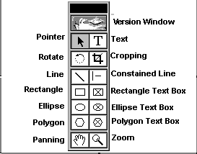

Using the Drawing Tools
- From the Toolbox, select the appropriate drawing tool
That tool will appear highlighted, and when you move the mouse over the working area of PageMaker, a crossbar (+) will move across the screen.
- Position the center of the crossbar (+) where the line or shape should start
- Click and drag the mouse in any direction to create a line or shape
Continue holding the mouse button down until the shape is positioned and is the desired size.
- Release the mouse button

Selecting Objects
A line or shape must be selected in order for it to be deleted, moved, or modified. When a graphic element is selected, it becomes surrounded by small boxes called handles, which are used for resizing. Lines and shapes are selected directly after they are drawn and stay selected until you draw another line or shape or until you click the mouse. You can reselect a line or shape by using the Pointer tool.

Selecting a Line or Shape
- From the Toolbox, select the Pointer tool
- With the tip of the pointer, click the line or shape
HINT: If the graphic element has a fill pattern, you can click on the fill pattern. The drawing should now have handles. If it does not, it is not selected and you must repeat this step, paying close attention to where the tip of the Pointer is positioned.

Selecting Multiple Lines and Shapes
- From the Toolbox, select the Pointer tool
- With the tip of the Pointer, click the first line or shape
The drawing should now have handles. If it does not, try again.
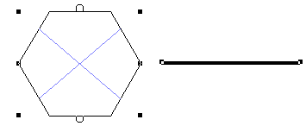
- Hold down the [Shift] key while clicking on other lines and shapes you want to select
- OPTIONAL: In order to select each layer of graphics, hold down the [Option] or [Ctrl] key while clicking on the graphic. The previous layers do not remain selected unless you are also holding down the [Shift] key.

Selecting with a Net
At times it may be difficult (and seem impossible) to select a drawing. If the drawing is made inside of a text block or too close to another drawing or graphic, you may have to use a Net (sometimes referred to as a coupon box) to select it. A net is a dashed line created with the Pointer tool. Any element fully enclosed by the net will be selected.
HINT: To capture a drawing that is within a text block or too near another element to select, create a net big enough to capture the complete drawing without capturing the complete text block or other element. This will select the drawing without selecting anything else.

To create a net
- From the Toolbox, select the Pointer tool
- Click the mouse in an area where you will not select anything (a margin would typically be a safe location)
- Hold and drag the net over the graphics you want to select
Notice that this creates a rectangular dashed line or net.
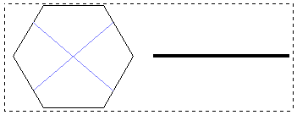
- Let go of the mouse button
The net will disappear and all elements—a drawing, a text block, or a graphic—that were completely enclosed by the net will now be selected.
- If you accidentally capture the wrong element or too many elements, don't panic. Just click away from the selected elements and they will deselect
OR
Hold down the [Shift] key and click on the desired elements to deselect them.

Choosing Line Style and Shape Fill Color
PageMaker allows you to alter the style of your lines; you can make them thin, medium, thick, dashed, dotted or graphic. You can also fill graphic elements like rectangles with grey fill colors or patterns. Line styles and fill colors are mutually exclusive; that is, drawings can have only one line style and one fill color applied at a time.

Selecting a Line Style
- Select the line you want to alter
- From the Element menu, select Stroke
- From the Stroke submenu, select your line style choice

Selecting a Fill Color
If you are drawing an enclosed shape (e.g., a square-corner box, a rounded-corner box, or a circle) you may also select a fill color.
- Select the shape you want to fill
- From the Element menu, select Fill
- From the Fill submenu, select your fill choice

Deleting an Object
- Select the line, shape or group of elements you want to delete using one of the selection methods
- Press [Delete]
OR
From the Edit menu, select Clear

Resizing Lines and Shapes
You can extend or shrink a line or shape using the handles. To modify a line or shape:
- From the Toolbox, select the Pointer tool
- Select the line or shape you want to modify
- Click and hold one of the element’s handles
A double-headed arrow will appear.
HINT: To keep a graphic element proportional, hold down the [Shift] key while dragging the handle for resizing.
- Drag the handle to resize the element
- Release the mouse button

Moving Lines and Shapes
If you like the overall appearance of the graphic element but you want to change its placement on the page, you can use the Pointer to drag the graphic. To move a line or shape:
- From the Toolbox, select the Pointer tool
- Select the line, shape or element(s) to be moved
HINT: To select more than one item, hold down the [Shift] key while selecting the items.
- Click and hold anywhere on the line or shape except on a handle
The Pointer will turn into a four-headed arrow.
- Still holding the mouse button, drag the element to a new location and release the button

Rotating Objects
Rotation of items and text helps you add interest to your document. With rotation, you can turn things upside down, tilt them to the left or right, and turn graphics around.
NOTES:
Rotating manually takes practice. Remember the Undo feature and keep trying until you get it right or try Rotating with the Control Palette.
If you are not sure about the type specifications that you want to use when rotating text, create a style and apply it to the text. Any modifications to the style will be made to the rotated text block.

Rotating with the Rotate Tool
- From the Toolbox, select the Rotate tool
- Select the item to be rotated
- Click and hold on one of the handles
- Drag to the desired angle
- Release the mouse button

To undo the rotation
- From the Edit menu, select Undo Rotate
NOTE: Undo must be selected immediately after the action you want to reverse.

Rotating with the Control Palette
- With the Pointer tool, select the text block or object you wish to rotate
- If the Control Palette (shown below) is not present, from the Window menu, select Control Palette
The Control Palette appears.
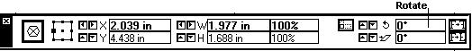
- In the Control Palette rotate box, type the number of degrees to rotate
- Press [Return]
- Repeat steps 3 and 4 as necessary

To undo the rotation
- With the Pointer tool, select the object
- In the Control Palette rotate box, type 0 (zero)
- Press [Return]
The object is restored to its original orientation.
Graphics placed as inline graphics become part of the text block. As you edit the text, the graphic retains its same relative position to the text but it will change position on the page (or may actually change pages) as you edit the text. Inline graphics are appropriate for documentation and reports where the graphic must accompany specific text.
Graphics can be cropped, sized, and moved in PageMaker, but no changes can be made to the graphic itself; that must be done in a graphics program, such as Adobe Phhotoshop.
- Placing an Inline Graphic
- Cutting and Pasting
- Moving an Inline Graphic

Placing an Inline Graphic
How you place a graphic is initially determined by your choice of either the Pointer tool or the Text tool. Inline graphics are placed using the Text tool.

To place an Inline graphic
- From the Toolbox, select the Text tool
- Set the insertion point where you want the image to appear
- From the File menu, select Place...
The Place dialog box appears.
- Select the image file you want to place
- In the Place section of the dialog box, verify that the graphic will be placed as an Inline graphic
If that option is not selected, click CANCEL and begin with step 1 again.
- Click OK

Cutting and Pasting
To cut and paste or copy and paste a line, a graphic, or a block of text:
- From the Toolbox, select the Pointer tool
- Select the graphic elements that you want to Copy or Cut
- From the Edit menu, select Copy or Cut
- Select the Text tool
- Place the cursor in the line of text you want the image inserted
- To paste the image, from the Edit menu, select Paste
WARNING: The computer will retain only one cut or copy at a time. If you select Cut and then highlight another item or items and select Cut or Copy, the first item or group of items will be replaced in memory by the second group and can no longer be pasted.

Moving an Inline Graphic
You have very little room in which to adjust an Inline graphic, but you can make some minor changes. An Inline graphic is confined to the boundary or baseline of the line of text it sits on.

To adjust the placement of an Inline image:
- Click on the graphic and hold the mouse button down
- The cursor turns into a two-sided arrow
NOTE: The image sits above the baseline of the text.
- While still holding the mouse button, drag the image down until it sits on the baseline
- When you have it placed properly, release the mouse button
Independent graphics are simply placed on the page. Regardless of what you do around the graphic, the placement will not change unless you move it.
- Placing Independent Graphics
- Sizing Independent Graphics
- Moving Graphics
- Cutting and Pasting Independent Graphics
- Layering of Graphics and Text
- Using Text Wrap

Placing Independent Graphics
How you place a graphic is initially determined by your choice of either the Pointer tool or the Text tool. Independent graphics are placed using the Pointer tool. If you have the Text tool selected, you can still place the graphic as an independent graphic by making the appropriate selection in the Place dialog box.
- From the Toolbox, select the Pointer tool
- From the File menu, select Place...
The Place dialog box appears.
- Select the image file you want to place
- In the Place section of the dialog box, verify that the graphic will be placed as independent graphic
If that option is not selected, select it now.
- Windows: Click OPEN
Your cursor will change to a graphics icon
- Use the mouse to position the icon’s top left edge where the top left corner of the graphic should appear in the document
- Click to place the graphic
- Select your Text Wrap option
See Using Text Wrap.
- Click OK

Inserting Clip Art from the Microsoft Clip Gallery
Images from the Clip Gallery are placed as independent graphics regardless of whether you use the Pointer tool or the Text tool when inserting them.
NOTE: This feature may not be available on all computers.
- From the Edit menu, select Insert Object...
The Insert Object dialog box opens.
Windows: Create New should be selected.
From the Object Type list, select Microsoft Clip Gallery
- Click OK
The Microsoft Clip Gallery opens.
- Select an image
- Click INSERT
The image appears on your page. You may resize, move, crop, layer or wrap text around it.

Sizing Independent Graphics
Once you have placed a graphic in your PageMaker document, you may discover that it is not the right size or it contains extra information that is not relevant to your document. With PageMaker’s ability to resize and crop graphics, you can make adjustments to the graphic so it better meets your needs. If you need to do additional editing, you probably need to use a graphics program such as Adobe Illustrator.
The following instructions cover how to reduce, enlarge, stretch, or crop part of a graphic.

Stretching or Shrinking a Graphic
- Using the Pointer tool, select the graphic you want to alter
- To change your image porportionately, click and drag one of the corner selection handles
OR
To change your image in height or width, click and drag one of the top, bottom, or side selection handles
HINT: To modify the object incrementally by .1 inch, hold the [Shift] key while dragging.
- Release the mouse button

Cropping Independent Graphics
Placing graphics often creates unnecessary white space along the sides of the image. You may also find that you only need a portion of a graphic. The Cropping tool functions somewhat like a scissors, cutting off the parts of the graphic you do not need or want.
- From the Toolbox, select the Cropping tool
- Select the image you want to crop
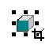
- To crop part of the image, click a handle and drag it inward
You should be able to see the handle through the center of the Cropping tool when you click on a handle for cropping.
- Release the mouse when the graphic is cropped correctly
HINT: If you decide later not to change the cropping, you can select the graphic with the Cropping tool and enlarge the frame to show more of the graphic or the entire graphic.

Panning Graphics
Panning a graphic allows you to adjust the portion of the image that is displayed after it has been cropped.
- From the Toolbox, select the Cropping tool
- Select the image you want to pan
- Position the Cropping tool in the center of the graphic
- Click and hold the mouse button
A small Hand icon will appear in the graphic.
- Hold the mouse button down and move the Hand icon within the graphic until the image is where you want it
- Release the mouse button

Moving Graphics
If your graphic is not placed in quite the right spot on the page, it can be moved.
To move an independent graphic:
- From the Toolbox, select the Pointer tool
- Select the graphic you want to move
- Click and hold anywhere on the graphic except on a handle
WARNING: If a two-sided arrow appears you may have grabbed a handle and accidently resized the graphic. To undo any resizing, release the mouse button and from the Edit menu, select Undo Stretch.
- Still holding the mouse button, drag the element to its new location and release the button
NOTE: If you have selected an in-line graphic, you will not be able to move it more than a few pixels up or down within the text. If you click on an in-line graphic and try to move it, you will see this arrow .

Cutting and Pasting Independent Graphics
To cut and paste or copy and paste a line, a graphic, or a block of text:
- From the Toolbox, select the Pointer tool
- Select the graphic elements that you want to Copy or Cut
- From the Edit menu, select Copy or Cut
- To paste the item(s), from the Edit menu, select Paste
WARNING: The computer will retain only one cut or copy at a time. If you select Cut and then highlight another item or items and select Cut or Copy, the first item or group of items will be replaced in memory by the second group and can no longer be pasted.

Layering of Graphics and Text
As you add more graphic elements and text to your document, the order that they appear on the page can make a difference on how the page looks. For example, if you have a shaded box and text in the same area of the page, the text has to be on top of the box in order for you to be able to read the text. So you do not have to create the graphics and text in the order that you want them to appear, PageMaker allows you to order the layers by sending them either to the front or to the back. To do this:
- With the Pointer tool, select the desired graphic or text block
- From the Element menu, select Arrange
- From the Arrange submenu, select Send to Back or Bring to Front

Selecting Text or Graphics behind Another Layer
To select text or graphics which are not on top
- Press [CTRL] and click the object

Using Text Wrap
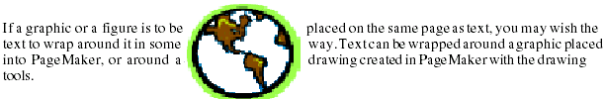

To use text wrap
- Select the graphic or drawing with the Pointer tool
- From the Element menu select Text Wrap...
The Text Wrap dialog box appears.
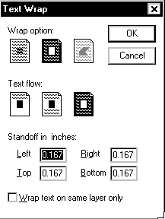
- Select the appropriate Wrap option:
- no wrap
- wrap around square
- wrap around non-standard shape
- Select the appropriate Text Flow option:
- above only
- above and below
- all around
- Type the standoff (the distance from surrounding text) in inches for each side of the graphic
- When settings and measurements are correct, click OK
To remove text wrapping
- Select the graphic or drawing with the Pointer tool
- From the Element menu select Text Wrap...
The Text Wrap dialog box appears on the screen.
- Select no wrap
- Click OK
PageMaker gives you a wide variety of options for using colors. Several colors are provided in the Color Library, but you may also create your own colors using PageMaker's color-matching system.
- Applying Colors
- Creating New Colors
- Selecting Colors from the Color Library
- Duplicating Colors
- Deleting Colors

Applying Colors
At the upper right hand corner of the Colors Palette, are three buttons
which you will use to specify what part of an object you want to color.
The STROKE button will apply the selected color to the line/border of a selected object.
The FILL button will apply the selected color to the inside of a selected object.
The BOTH button will apply the selected color to both the line and inside of a selected object.

To apply color to an object
- From the Window menu, select Show Colors
The Colors Palette appears.
NOTE: To resize the Colors Palette, drag the window from the lower right hand corner
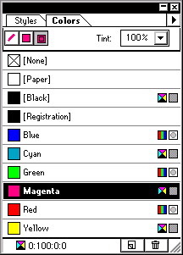
- Select the object to which you want to apply color
- To apply the selected color only to the border of your object, click the STROKE button
To apply the selected color only to the inside of your object, click the FILL button
To apply the selected color to the border and the inside of your object, click the BOTH button
NOTE: You can apply separate colors to the border and to the inside.
- To apply a color, click the desired color

Creating New Colors
PageMaker provides you with three options in designing a new color:
- RGB: Red, Green, and Black
- HLS: Hue, Lightness, and Saturation
- CMYK: Cyan, Magenta, Yellow, and Black

To create a new color
- In the Colors Palette, at the lower right corner, click the NEW COLOR BUTTON
OR
From the Palette menu , select New Color...
The Color Options dialog box appears.
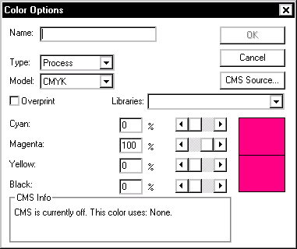
- From the Model pull-down list, select an option to use in creating the color
Text boxes appropriate to the model you have chosen appear below.
- In the value text boxes, type the values or use the scroll bar to create the color you want
In the Preview box, you will see the color change as you make adjustments.
- After you have created the desired color, in the Name text box, type a name for your new color
- Click OK
The new color appears in the Colors Palette.

Selecting Colors from a Color Library
If your PageMaker publication will be commercially printed, it will be important to have the colors of your publication reproduced as accurately as possible. When choosing a custom color, faithful reproduction of it will be easier to achieve if you select the color from a color library, which contains various color-matching systems supported by commercial printers.
NOTE: Before selecting colors, be sure to check with your printer as to which color-matching systems they support.
- In the Colors Palette, at the lower right corner, click the NEW COLOR BUTTON
The Color Options dialog box appears.
- From the Libraries pull-down list, select a color-matching system
- To locate the color you want, use the scroll bar
- Select the color by clicking it
- Click OK
- In the Color Options dialog box, in the Name text box, type a name for the new color
- Click OK

Duplicating Colors
Once you have created a color, you may want to create another color based on it (e.g., a darker or lighter shade). By duplicating the original color, you will have a copy which you can edit without affecting objects filled with the original color.
- From the Colors Palette, select the color you wish to duplicate
- From the Palette menu, select Duplicate...
The Color Options dialog box appears.
In the Name text box, the name of the selected color will appear followed by the word copy, (e.g., blue copy).
- In the Name text box, type a new name for the copy
- Click OK
The duplicated color will appear in the Color Palette list under its new name.

Deleting Colors
You can delete colors from the Colors Palette that you are not using in your publication or no longer want.
NOTE: You cannot remove the following colors: None, Paper, Black and Registration.
WARNING: Deleting a color from the Colors Palette will recolor all objects and text of that color to black.
- On the Colors Palette, select the color you wish to delete
- In the lower right corner of the Colors Palette, click the TRASH BUTTON
OR
From the Palette menu , select Delete...
A confirmation dialog box appears.
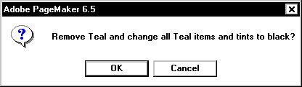
- To delete the selected color, click OK
OR
To cancel, click CANCEL
The Color Library is a custom set of colors that you create. You may want to create a Color Library for specific projects or simply to maintain and quickly access the colors you use most frequently. This document contains sections on the following topics:
- Creating a Color Library
- Viewing or Using a Color Library

Creating a Color Library
- Create or open a publication
- To view the current Color palette, from the Window menu, select Show Colors
The Color Palette appears.
- OPTIONAL: Modify the Color listing to display the colors you want in your library by adding, deleting, or duplicating colors by accessing the Color palette from the right arrow button
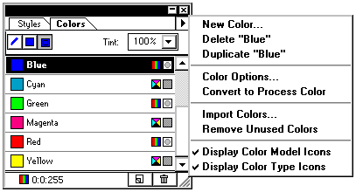
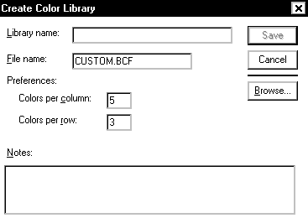
- From the Utilities menu, select Plug-Ins » Create Color Library...
The Create Color Library dialog box appears.
- In the Library name textbox, type the desired name
NOTE: The name that you choose will appear on the Library menu in the New Color dialog box.
- In the File name textbox, type the desired filename
NOTE: PageMaker automatically appends the filename with the .BCF (binary color file) extension
- OPTIONAL: In the Preferences section of the dialog box, adjust the Colors per column and Colors per row numbers (up to 10x10)
- OPTIONAL: In the Notes textbox, add notes that will appear when someone clicks the ABOUT button in the Library dialog box
- Click SAVE
NOTE: All color files must reside in the Color folder, which is inside the Language folder; the default saves in the correct location.

Viewing or Using a Color Library
- To open the Color palette if it is not already open, from the Window menu, select Show Colors
- At the bottom of the Color palette, click the NEW COLOR button
OR
Choose New Color from the Color palette menu
The Color Options dialog box appears.
- Select a color library name from the Libraries pull-down menu
The selected color library appears in the Color Picker dialog box.
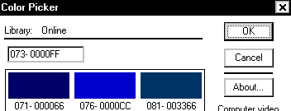
- OPTIONAL: Click ABOUT... to see any notes written by the author of that color library
- To accept the selected color library, click OK
A style is simply a definition of the type, paragraph, tab, and hyphenation settings for a specific type of text in your document.
Styles are helpful for documents that have several formatting changes (e.g., titles, section headings, text, lists) and for projects that more than one person is working on. Styles can make documents more consistent and they will save you time (especially if you decide to make global changes to your document).
You are already familiar with much of the work that goes into creating styles because you know how to define your type specifications. There are two basic steps to working with styles:
- Define the style
- Apply the style
As with most programs, planning ahead and thinking about your document can save you a lot of time when creating and modifying your styles. This document contains the following sections:
- Creating a Style
- Applying a Style
- Editing a Style

Creating a Style
You have several options while creating a style. For example, you can define a new style based on an already existing one and/or work ahead by choosing a style for the paragraph following the newly created one.
- From the Type menu, select Define Styles...
The Define Styles dialog box appears.
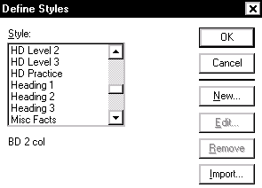
- Click NEW...
The Style Options dialog box appears.
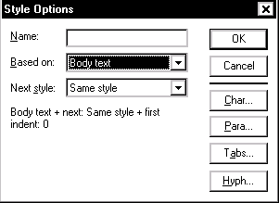
- In the Name box, type a name for your new style
- OPTIONAL: To define a new style based on an already existing one, from the Based on pull-down listing, select the desired existing style
If you like everything about a style except the tab stops, you can change the tabs and give the style a new name - everything else will remain the same.
- OPTIONAL: To select a style for the paragraph following the newly created paragraph style, from the Next style pull-down listing, make the desired selection
- Define the style by making the appropriate changes through the following buttons:
CHAR...
Used to define the type specifications including font, type size, leading and enhancements (e.g., boldfacing).

PARA...
Used to define the paragraph specifications including paragraph margins, space between paragraphs, widow/orphan control and page/column break control.

TABS
Used to define the tab settings.

HYPH...
Used to turn hyphenation on and off and for controlling the hyphenation process.

- To close the Style Options dialog box, click OK
- To close the Define Style dialog box, click OK

Applying a Style
Applied styles will affect the text from paragraph return to paragraph return. To apply a style for one complete paragraph, you need to place your insertion point within the paragraph. When you want to apply a style to multiple paragraphs at once, you must select at least one character from each paragraph.

Applying a Style Using the Menu
- Place the insertion point within or highlight the paragraph you want to apply the style to
- Windows: From the Type menu, select Type Style » select the appropriate style
Applying a Style Using the Style Palette
- If necessary, to display the Style Palette, from the Window menu, select Show Styles
The Style Palette appears.
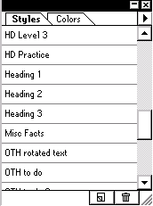
- Place the insertion point within or highlight the paragraph you want to apply the style to
- From the Style Palette, select the appropriate style

Editing a Style
You may decide later that the specifications originally set for a style are not what you want. You can edit the style so that the change you make occurs for every instance of that style in your document.
- From the Type menu, select Define Styles...
- From the list of style names, select the style that you want to edit
- Click EDIT
- Make the appropriate changes using the TYPE, PARAGRAPH, TABS, and HYPHENATION buttons
- To close the Style Options dialog box, click OK
- To close the Define Style dialog box, click OK
Master pages act as template pages for your document. Master pages save you time because they allow you to type or draw information once on the master pages so that this information appears on all the pages of your document.
Depending on what type of document you are creating, master pages may or may not be a useful feature for you. It is most useful when creating documents where the same elements need to appear at the same location on each (or at least most) pages.
- Design Elements
- Formatting Master Pages
- Creating Additional Master Pages
- Applying Master Pages
- Displaying Master Elements
- Hiding Master Elements
- Numbering Pages

Design Elements
Some elements that might be useful to include on your master pages:
- a layout grid (with non-printing ruler guides)
- page numbers, headers and footers
- any graphic that you want to appear at the same location on every page
- column guides

Formatting Master Pages
- Click the L/R page icons
- Add all text and graphic elements that you want to appear on each page of your document and create any necessary columns
- When finished, click the icon for the page(s) you want to view

Creating Additional Master Pages
By default, the Document Master is applied to all pages in your initial publication. For some pages of your publication, it might be helpful to have a different master page to apply. After creating additional master pages, PageMaker will display the newly created master page in the publication window and add its name to the Master Pages palette.
- From the Window menu, select Show Master Pages...
The Master Pages palette appears.
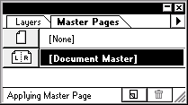
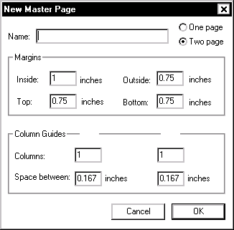
- From the Master Pages palette, select New Master Page...
The New Master Page dialog box appears.

- In the Name textbox, type a name for the master
- Specify whether you would like a single page or a two-page spread
- In the Margins and Column Guides sections, format your page(s) as desired
- Click OK

Applying Master Pages
By default, the Document Master is applied to all pages in your initial publication. To apply elements from another master page to a page in your publication, do the following:
- Move to the page(s) on which you want the master items displayed
- From the Master Pages palette, select the master page you would like to apply

Displaying Master Elements
The Display Master Items feature may already be activated through PageMaker's default settings. If you are not seeing the master page items on your document, do the following:
- Move to the page on which you want the master items displayed
- From the View menu, select Display Master Items
The selection will have a checkmark next to it.

Hiding Master Elements

Hiding All of the Elements
- Move to the page on which you do not want the master items displayed
- From the View menu, remove the checkmark from Display Master Items

Hiding Selected Elements
- Using the rectangle tool and the shading options, draw a white rectangle over the items you wish to hide
For more information about doing this see Drawing with PageMaker.

Numbering Pages
To have PageMaker automatically do the page numbering:
- On a master page, with the Text tool, create a text box
- Windows: Press [Ctrl]+[Alt]+[P]
When this is done on a master page, either RM (right master) or LM (left master) will appear. When you move to a "regular" page, the proper page number will appear.
A template is a document with preset formatting and settings. For example, if you were creating a newsletter, you could set the margins, columns, and guides where they need to be and use the same file to create all your issues. This maintains consistency throughout the issues.
If none of the existing PageMaker templates fit your needs, you can create and modify your own template. The same template can be used over and over again without making changes to the original.
- Creating a Template
- Using the Template
- Modifying the Template
- Using a Standard Template

Creating a Template
If you create a publication design that you will be using repeatedly, you can save the design format as a template.
- Create a new PageMaker document
For more information, refer to PageMaker Basics
- Design the document
(i.e., set ruler and column guides, place graphics, define styles)
- From the File menu, select Save As...
The Save As... dialog box appears.
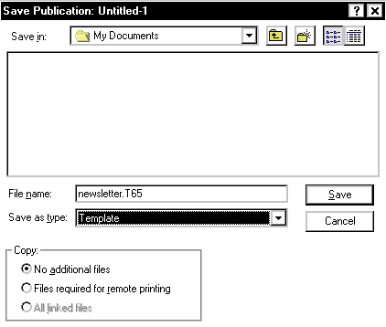
- Under File Name, type a name for the template
- From the Save as type pull-down menu, select Template
- Click SAVE

Using the Template
You can use a template again and again for different publications. Each time you open the template, PageMaker will open a copy of the document and not the original. Any changes made to the copy of the template will need to be saved under a different name.
- From the File menu, select Open...
The Open Publication dialog box appears.
- In the Files of Type pull-down list, select All Files
- Maneuver to the proper folder and select a template
- Click OK
- Develop your document
- To save the changes to the document, from the File menu, select Save As...
- Under File Name, type a name for the document
- Under Save as Type, select Publication
- Click SAVE

Modifying the Template
If you find that you need to make a few changes to your existing template, you can make changes to the original document without having to create a new one.
- From the File menu, select Open...
The Open Publication dialog box appears.
- In the Files of Type pull-down list, select All Files
- Maneuver to the proper folder and select a template
- Click OK
- Under Open As, select Original
- Click OPEN
- Make the necessary changes to the document
- From the File menu, select Save As...
The Save As... dialog box appears.
- Under Save as Type, select Template
You do not have to rename the file.
- Click SAVE
A dialog box will appear asking if you want to replace the existing file.
- Click YES

Using a Standard Template
PageMaker comes with an assortment of templates, from brochures to newsletter designs. You can work with these templates or modify them to meet your needs.
- From the Window menu, select Plug-in Palettes » Show Scripts
The Scripts list box appears.
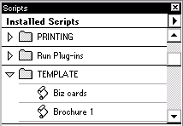
- Scroll down the Scripts listing and click TEMPLATE
- From the Template sub-listing, double click the desired template
NOTE: If you do not have the template fonts installed on your computer, you will be prompted to specify substitute fonts.
- To save the template as a document, from the File menu, select Save As...
The Save As... dialog box appears.
- Under File Name, type a name for the document
- Under Save as Type, select Publication
- Click SAVE
This document contains sample setup dimensions of a Tri-fold brochure. Using the setup specifications listed here will result in a tri-fold brochure with three panels on each side that can be used for text and/or graphics. The column guides allow for three columns with sufficient room for folding.
For more information on setting up documents see About the Document Setup Dialog Box.
- Document Setup
- Column Guides Setup

Document Setup
- From the File menu, select New...
The Document Setup dialog box appears.
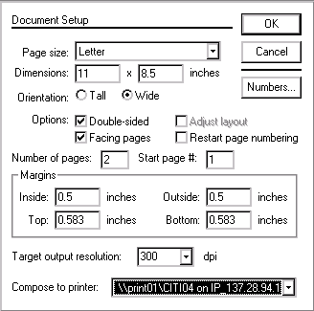
- From the Page size pull-down menu, select Letter
- By Orientation, select Wide
- By Options, make sure Double-sided and Facing are selected
- In the Number of Pages text box, type 2
- Under Margins, in the Inside and Outside text boxes, type 0.5
- Under Margins, in the Top and Bottom text boxes, type 0.583
- Click OK

Column Guide Setup
- From the Layout menu, select Column Guides...
The Column Guides dialog box appears.
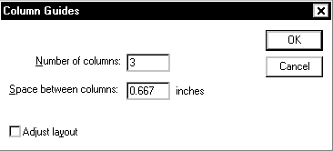
- In the Number of Columns text box, type 3
- In the Space between Columns text box, type 0.667
- Click OK
Your brochure appears as follows, and is now ready for text and graphics.
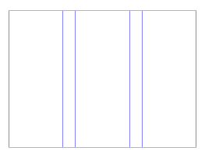
Using the setup specifications listed here will result in a booklet-style brochure with two panels on each side of the page that can be used for text and/or graphics. Two setups are provided. The two-page booklet uses columns to separate the "pages". The four-page booklet uses the Build Booklet feature to assist with layout.
For more information on setting up documents see About the Document Setup Dialog Box.
- Two-Page Booklet
- Four-Page Booklet
- Using Build Booklet

Two-Page Booklet
The document and column setups given here result in a grid like the one shown. Columns divide a standard 8.5" X 11" sheet into two "pages." The Space between columns measurement gives sufficient room for folding.
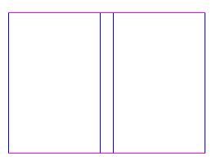

Document Setup
- From the File menu, select New...
The Document Setup dialog box appears.
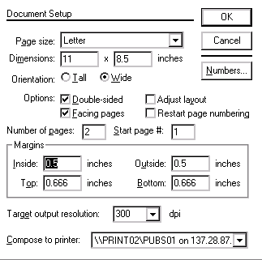
- From the Page size pull-down menu, select Letter
- By Orientation, select Wide
- By Options, make sure Double-sided and Facing are selected
- In the Number of Pages text box, type 2
- Under Margins, in the Inside and Outside text boxes, type 0.5
- Under Margins, in the Top and Bottom text boxes, type 0.666
- Click OK

Column Guide Setup
- From the Layout menu, select Column Guides...
The Column Guides dialog box appears.
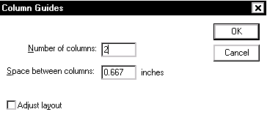
- In the Number of Columns text box, type 2
- In the Space between columns text box, type 0.667
- Click OK
Your brochure is now ready for text and graphics.

Four-Page Booklet
The document setup given here results in a grid like the one shown. The setup provides four individual pages and allows you options that the two-page booklet does not. For example, you can use master pages to format specific pages. This setup also allows you to easily expand the booklet, if needed, by one or more pages.
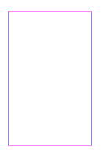

Document Setup
- From the File menu, select New...
The Document Setup dialog box appears.
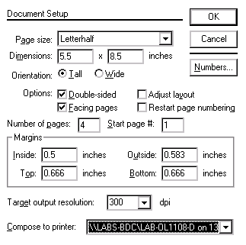
- From the Page size pull-down menu, select Letterhalf
- By Orientation, select Tall
- By Options, make sure Double-sided and Facing are selected
- In the Number of Pages text box, type 4
- Under Margins, in the Inside text box, type 0.5
- Under Margins, in the Outside text box, type 0.583
- Under Margins, in the Top and Bottom text boxes, type 0.666
- Click OK
Your booklet is now ready for text and graphics.

Using Build Booklet
Use the Build Booklet plug-in once you have completed the layout of your text and graphics. When you print front to back on your paper, the pages of the booklet will be ordered correctly.
Small changes can be made to the publication once you have run Build Booklet. However, be careful of making changes that may alter the flow of text and therefore the organization of your pages. If you need to make substantial changes after you have run Build Booklet, make them in the original publication and then re-run Build Booklet.
NOTE: Build Booklet creates a new publication so be sure that you have sufficient drive or disk space to accommodate it.

To run Build Booklet
- From the Utilities menu, select Plug-ins » Build Booklet...
The Build Booklet dialog box appears.
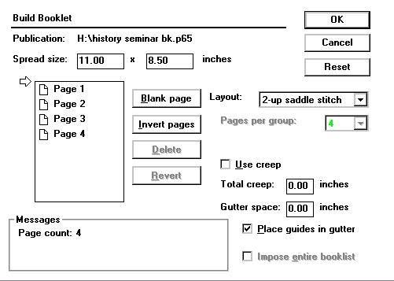
- From the Layout pull-down list, select 2-up saddle stitch
- Click OK
A dialog box appears asking if you want to save your original publication before it is closed.
- Click YES
A new, untitled publication is created. You are now ready to print. You may also want to save this new layout of your publication, giving it a different name than your original publication.
Many publications use jump lines ("Continued on..." and "Continued from...") to tell the reader where to find the next or previous section of a story. If you've created your columns with text blocks, PageMaker can automate this process by adding a one-line text block after the last text block on a page ("Continued on...") and before the first text block on a page ("Continued from...").
PageMaker's plug-in shortens the selected text block by one line and places a jump line story with the correct page number. To make it easy to format jump lines, two new styles are automatically added to your style sheet: Cont. From and Cont. On (see PageMaker Styles).
WARNING: Perform this step when layout and pagination are finalized; although PageMaker initially supplies the correct page number, the number is not updated when changes in pagination occur.
- Finalize the layout of the publication
- With the pointer tool, select the text block on the page where you want the jump line
- From the Utilities menu, select Plug-ins » Add cont'd line...
The Continuation notice dialog box appears.
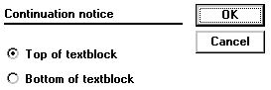
- Specify whether you want to add the jump line to the top or bottom of the text block
- Click OK
Sometimes you want the columns on a page to be of equal size, so that their top and bottom edges align. If you have used text blocks to contain the text, PageMaker can automatically calculate the average length of selected columns and then resize them to that length.
- With the pointer tool, select two or more columns (i.e., text blocks) within the same story
HINT: Hold down the [Shift] key to select multiple columns. You can select anywhere from 2 to 40 columns.
- From the Utilities menu, select Plug-ins » Balance Columns...
The Balance columns dialog box appears.
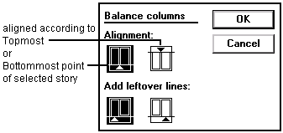
- Under the Alignment section, select an alignment option
- Under the Add leftover lines section, select where you want leftover lines added (left or right column) when text cannot be divided evenly among the selected columns
NOTE: Leftover lines are the lines at the end of the story that do not fit into evenly balanced columns.
- Click OK
Once you have formatted a hanging indent, you can use the following techniques to quickly add bullets or consecutive numbers (each followed by a tab) to a set of consecutive paragraphs, to every paragraph of a certain style, or to every paragraph in the selected story. Make sure your numbering scheme is final before using this technique; if the paragraphs change, the numbers are not automatically updated.
HINTS:
If you need to change the order of your paragraphs, remove the numbering, make changes, then reapply.
You may also want to adjust paragraph margins for hanging indents.
- Adding Bullets Automatically
- Adding Numbers Automatically
- Removing Bullets or Numbering

Adding Bullets Automatically
Bullets are useful for unordered lists. You can create any type of bullet style by using the standard style selections or customizing the font, size, or character of a bullet.

Adding Bullets Automatically: Standard Bullet
- With the text tool, click an insertion point in the first paragraph you want to change or select a range of paragraphs
- From the Utilities menu, select Plug-ins » Bullets and Numbering...
The Bullets and numbering dialog box will appear.
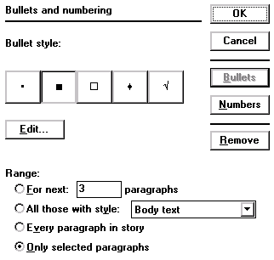
- If necessary, click BULLETS to show bullet style options
- Select one of the supplied bullet characters
- From the Range section, select a range
- Click OK

Adding Bullets Automatically: Custom Bullets
- With the text tool, click an insertion point in the first paragraph you want to change or select a range of paragraphs
- From the Utilities menu, select Plug-ins » Bullets and Numbering...
The Bullets and numbering dialog box will appear.
- If necessary, click BULLETS to show bullet style options
- Select a bullet style or stay with the default selection
- To change the font or size of a bullet:
  - Click EDIT...
The Edit Bullet dialog box appears.
  - Make desired changes to the Font or Size pull-down lists
  - Click OK
- To specify a different character:
  - Click EDIT...
The Edit Bullet dialog box appears.
  - Select another character by clicking that character's button
NOTE: Selecting a different font may change the characters available.
  - Click OK
- From the Range section, select a range
- Click OK

Adding Numbers Automatically
The automatic numbering option is very helpful if you have the order of your list items finalized.
- Click an insertion point in the first paragraph you want to change or select a range of paragraphs
- From the Utilities menu, select Plug-ins » Bullets and Numbering...
The Bullets and numbering dialog box will appear.
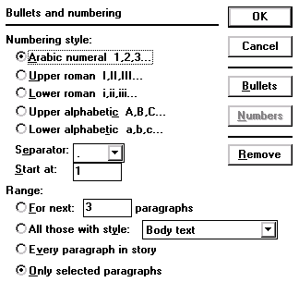
- If necessary, click NUMBERS to show numbering style options
- In the Numbering style section, select the desired style
- From the Separator pull-down listing, select the desired separator
NOTE: The separator is the character between the number and THe Tab ThAt follows it.
- In the Start at text box, type a beginning number
- In the Range section, select the desired ran‚e
NOTE: If the Range type you selected has a text box or pull-down listing, type in the information or make a selection from the listing.
- Click OK

Removing Bullets or Numbers
If you decide not to use bullets or numbers, or the numbering is incorrect, you may need to remove the bullets or numbers.

Removing Bullets or Numbers: Keyboard Option
- Select the bullet or number and press [Delete]

Removing Bullets or Numbers: Menu Option
- Select the paragraph(s) with bullets or numbering to be removed
- From the Utilities menu, select Plug-ins » Bullets and Numbering...
The Bullets and Numbering dialog box will appear.
- Click REMOVE
A message saying Remove bullet or number from the start of each paragraph in the specified range? will appear.
- Click OK
PageMaker provides three type-case attributes: Normal leaves uppercase and lowercase letters as typed; All Caps displays letters as full-sized capitals; and Small Caps displays lowercase letters as small capitals, based on the size specified.
- Terminology
- Changing the Text Case

Terminology
Lower Case
All the letters are not capitalized
Example: this selection is lower case
Upper Case
All the letters are capitalized
Example: THIS SELECTION IS UPPER CASE
Title Case
The first letter of each word will be capitalized; the rest of the letters are not capitalized
Example: This Selection Is Title Case
Sentence Case
The first letter of a word beginning a sentence will be capitalized; the rest of the letters are not capitalized
Example: This selection is sentence case. The capital letter comes after an end punctuation mark.
Toggle Case
The letters that are currently not capitalized will be changed to upper case; the letters that are currently capitalized will be changed to lower case
Example: tHIS sELECTION iS tHE tOGGLE cASE vERSION oF a tITLE cASE sAMPLE

Changing the Text Case
To quickly change capitalization of a selected range of text, use the following instructions:
- With the Text tool, select the text you wish to change capitalization of
NOTE: Make sure the [Caps Lock] key is not on. You cannot change case through any method while the [Caps Lock] key is on.
- From the Utilities menu, select Plug-ins » Change Case...
The Change Case dialog box appears.
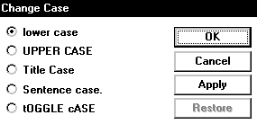
- Select the desired option
- OPTIONAL: To see the selected case applied to the text without closing the dialog box, click APPLY
NOTE: To change the case of the text selection back to the previous case, click RESTORE
- Click OK
Drop caps can be used to add interest to a document. In PageMaker, a drop cap can be applied only to the first character of a paragraph. Drop caps work best with longer paragraphs (generally at least 3-5 lines) but this varies on the specifics of your drop cap.
- Applying a Drop Cap
- Removing a Drop Cap
- Modifying a Drop Cap

Applying a Drop Cap
To reduce the likelihood of needing to reapply a drop cap, it is best to make this a final step in the production of your document. If the text on the first few lines of the paragraph is edited after the drop cap is applied, the lines surrounding the drop cap will not be formatted correctly.
- OPTIONAL: If desired, change the font of the first character of the paragraph
NOTE: It is recommended that you select the font for your drop cap before applying the drop cap.
- With the text tool, place your insertion point within the paragraph
- From the Utilities menu, select Plug-ins » Drop cap…
The Drop cap dialog box appears.
- In the Size text box, type in how many lines the drop cap should extend into
- OPTIONAL: To change the next or previous paragraphs, in the Go to paragraph section, click PREV or NEXT
- OPTIONAL: To preview the drop cap while still in the dialog box, click APPLY
HINT: In order to see the drop cap, you may need to move the Drop cap dialog box.
- Click OK
OR
If you previously clicked APPLY, click CLOSE

Removing a Drop Cap
If you decide that you do not want the drop cap, you can remove it through the Drop cap dialog box. If you try to simply delete the drop cap and retype the letter in regular text, the part of the drop cap and the space cleared for it below the line will not be removed.
- With the text tool, place your insertion point within the paragraph with the drop cap
- From the Utilities menu, select Plug-ins » Drop cap…
The Drop cap dialog box appears.
- Click REMOVE
- Click CLOSE

Modifying a Drop Cap
If you decide that a different size would be better for the drop cap, you can modify the drop cap by removing and reapplying a drop cap through the Drop cap dialog box. If you decide that a different font would be better for the drop cap, you can modify the drop cap by changing the font, then resizing the window to correct the view.

Modifying a Drop Cap: Size
- With the text tool, place your insertion point within the paragraph with the drop cap
- From the Utilities menu, select Plug-ins
- From the submenu, select Drop cap...
The Drop cap dialog box appears.
- Click REMOVE
- In the Size text box, type in how many lines the drop cap should extend into
- OPTIONAL: To preview the drop cap while still in the dialog box, click APPLY
- Click OK
OR
If you previously clicked APPLY, click CLOSE

Modifying a Drop Cap: Font
- Select the drop cap
- From the Type menu, select Font
A submenu appears.
- Select a suitable font
- Reset the display by using the Zoom tool
OR
Windows: Reset the display by clicking RESIZEor MAXIMIZEto
The screen display will resize larger or smaller and you will be able to see the new font drop cap.
HINT: If the new font you selected is smaller than the first font, you may have empty space around the bottom of the drop cap. To get rid of this space, you will have to remove the drop cap, change the font separately, then reapply the drop cap.
- OPTIONAL: Resize back to whatever size screen display you were working with
The Grid Manager allows you to create a grid of horizontal and/or vertical lines automatically instead of manually. Two of the uses are business cards and note cards. You must decide if you want word wrapping within the grid or if the words can go over the gridlines before you decide what kind of guides to use in your grid. Column guides force word wrapping while Ruler guides simply mark divisions.
- Creating a Grid
- Example Grids

Creating a Grid
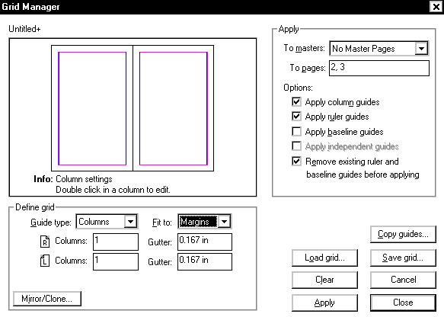
- From the Utilities menu, select Plug-ins » Grid Manager...
The Grid Manager dialog box appears.
- In the Apply section of the dialog box, from the To masters pull-down listing, select the desired option
- In the Apply section of the dialog box, in the To pages text box, type in a page number or range
- In theApply section of the dialog box, under Options, select the items that you would like to use
- In the Define grid section of the dialog box, from the Guide type pull-down listing, select the desired choice
NOTES:
Columns sets the number of columns designated, evenly divided within the page or page margins. Column guides force word wrapping.
Rulers sets horizontal rules indicating rows across the page, evenly divided within the page or page margins. Ruler guides simply mark divisions and do not force word wrapping.
Baseline sets horizontal rules based on a designated pica placement with the page or page margins.
- Fill in the corresponding Columns, Row, or Baseline text boxes with appropriate divisions or measures
NOTE: The text boxes change according to which Guide type and Options are chosen.
- OPTIONAL: After defining one guide selection, another selection can be chosen and layered on top by following steps 6 and 7 again
- In the Define grid section of the dialog box, from the Fit to pull-down listing, select the desired choice
NOTES:
Margins make the designated changes with the set page margins.
Page makes the designated changes with the physical page margins.
- Fill in the corresponding Gutter text boxes with appropriate measures
- When done, click CLOSE
The grid will be created.

Example Grids
Selecting more than one type of guide allows different options.The first grid was created using only Column guides, dividing the pages into 3 columns each. The second grid was created using only Ruler guides, dividing each page into 2 columns and 6 rows. The third grid was created using Column guides, dividing the pages into 3 columns each, and Ruler guides, dividing the page into 2 columns and 6 rows. All the guides were fit to Margins in these examples.
1. Column guides only (3 each) | 2. Ruler guides only (2x6 each)
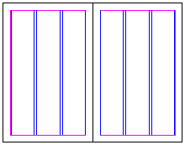 | 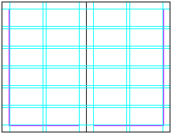
3. Both column and ruler guides
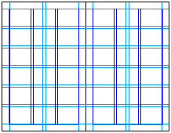

The Build Booklet plug-in lets you create publications in which pages are arranged for printing multi-page spreads (e.g., a book). The arrangement of pages printed on a single sheet or form is called an imposition. The Build Booklet plug-in creates multiple page spreads that print on a single sheet and assume the correct page order when folded. When you stack, bind, and trim the folded double-sided booklets, the result is a single book with correct pagination.
Running Build Booklet should be the final step before printing your publication. Build Booklet closes the current publication and creates a new, untitled publication with the page size equal to the size of the imposition. Build Booklet then calculates the proper page sequence and transfers the master and publication page items from the original publication to the correct pages in the new publication. Build Booklet can rearrange pages in the active publication or for all publications in a book list.
- Accessing the Build Booklet Dialog Box
- Selecting a Layout
- Adjusting Spread Size
- Adding, Deleting, or Revising Blank Pages
- Additional Options
- Using the Total Creep
- Running Build Booklet

Accessing the Build Booklet Dialog Box
- Create the publication (see Creating a New Document in PageMaker Basics)
HINT: In the document setup, a paper size of Letter Half or Legal Half would be an appropriate choice.
- Save the publication (see Saving a File Using Save As... ) in PageMaker Basics)
- From the Utilities menu, select Plug-ins » Build Booklet...
The Build Booklet dialog box will appear.
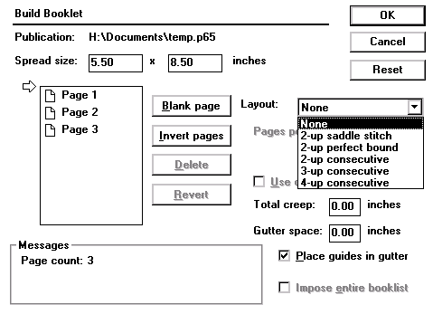

Selecting a Layout
Review the following table to learn about layout options:
Layout Option | Description
*2-up saddle stitch | This option is for standard booklet printing. Double-sided pages are folded once and fastened along the fold (i.e., first page prints on the same page as the last page, the second page on the same sheet as the second-to-last page). When the pages are printed front to back and folded, they are in correct sequence.
*2-up perfect bound | This option creates a series of folded booklets which are bound in a group with adhesive along the spine. With this option, you select the number of pages per booklet (4, 8, or 16), and PageMaker calculates how many booklets are needed for the publication.
2-up consecutive | This option combines each set of 2 pages side-by-side on a single page. This option is appropriate for creating a 2 panel brochure.
3-up consecutive | This option combines each set of 3 pages side-by-side on a single page. This option is appropriate for creating a 3 panel brochure.
4-up consecutive | This option combines each set of 4 pages side-by-side on a single page. This option is appropriate for creating a 4 panel brochure.
None | This option creates a new publication, but does not rearrange the pages or change the spread size. You can manually adjust the page arrangement, increase the page size, or insert blank pages.
*2-up saddle stitch and 2-up perfect bound are most common
- Access the Build Booklet dialog box
- From the Layout pull-down listing, select the desired choice
HINT: For publications with more than 80 pages, it’s best to use the 2-up perfect bound option rather than 2-up saddle stitch option, since folding more than 20 separate sheets of paper creates layout problems.
- OPTIONAL: If your layout selection is 2-up perfect bound, you may adjust Pages Per Group by choosing a number from the pull-down listing
- OPTIONAL: Continue with Adjusting Spread Size, Adding, Deleting, or Revising Blank Pages, Additional Options, or Using Total Creep
- Run Build Booklet

Adjusting Spread Size
When you choose an imposition layout (and later if you specify a gutter size), Build Booklet automatically calculates the spread size and displays it in the Spread Size text box. You can adjust these measurements to provide room for printer’s marks.
A warning appears in the Messages section if the current spread size is not large enough for the publication or if it exceeds the maximum page size.
- Access the Build Booklet dialog box
- In the Spread Size text boxes, type the desired dimensions
- OPTIONAL: Continue with Adding, Deleting, or Revising Blank Pages, Additional Options, or Using Total Creep
- Run Build Booklet

Adding, Deleting, or Revising Blank Pages
The message area of the Build Booklet dialog box indicates the number of pages you need to add (if any) to meet the correct page count for the specified layout. If the layout option you have chosen requires blank pages and you do not add them, Build Booklet inserts the needed blank pages at the end of the publication.

To add blank pages:
- Access the Build Booklet dialog box
- Place the arrow next to the page listing where you want the blank page to appear
- Click BLANK PAGE
A blank page is placed and the Messages section will adjust information on how many blank pages are still needed to complete your selected layout.
- OPTIONAL: Continue with Additional Options or Using Total Creep
- Run Build Booklet

To delete blank pages:

Access the Build Booklet dialog box
- Select the page you want to delete
- Click DELETE
The blank page is removed.
- OPTIONAL: Continue with Additional Options or Using Total Creep
- Run Build Booklet

To revise the order of blank pages:

Access the Build Booklet dialog box
- To move a page:
  - Select the page you want to move
  - Windows: Press and hold [Alt]
  - Drag the page to its new location
  - Windows: Release [Alt]
- To reverse the order of pages, click INVERT PAGES
NOTE: All pages are inverted with this option.
- OPTIONAL: Continue with Additional Options or Using Total Creep
- Run Build Booklet

To return to the original publication copy (in case of any unwanted changes):
- Click REVERT
- OPTIONAL: Continue with Additional Options or Using Total Creep
- Run Build Booklet

Additional Options
Some additional options may not always be available because the layout selection you choose may affect which options are available.
Access the Build Booklet dialog box
- To add space between pages, in the Gutter space text box, type a value
When you type a value for Gutter space, the Spread size values automatically adjust.
- To place non-printing ruler guides in the publication, select Place Guides in Gutter
- OPTIONAL: Continue with Using Total Creep
- Run Build Booklet

Using the Total Creep
To adjust the placement of page items to account for paper thickness, use the following instructions:

Access the Build Booklet dialog box
- Select Use Creep
NOTE: To determine the value for creep, consult your commercial printer
- In the Total creep text box, type a value
This does not change the Spread size.
- Run Build Booklet

Running Build Booklet
- In the Build Booklet dialog box, click OK
An informational message will appear asking if you would like to save your current publication before it is closed and the booklet publication opened.
- Windows: Click OK
After processing the document, an untitled document will appear that has your document in book format.
After the new publication is created, you can manually edit the publication. For example, you can delete page numbers from blank pages. The master pages of the new publication, however, are blank; all master page information has been copied to each page of the new publication.
Running headers and footers are similar to page headers and footers; however, the running headers and footers are applied to a story rather than a page. If the story continues onto another page, the running header and footer will repeat. If the story does not appear on the page, the running header and footer will not appear.
As this information is not automatically updated if the layout of the document changes, applying running headers and footers should be done in the final stages of production.
- Applying a Running Header or Footer
- Previewing the Document

Applying a Running Header or Footer
Since the running header and footer is not updated if the document changes, apply them in the final stages of production.
- With the pointer tool, select the desired story
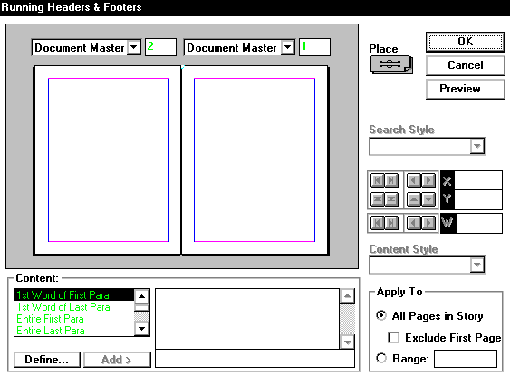
- From the Utilities menu, select Plug-ins » Running Headers & Footers...
The Running Headers & Footers dialog box appears.
- Click the PLACE icon
A Place symbol will appear on the blank page
- Drag the Place symbol to the desired location
- In the Content text box, type any words you would like to stay constant in the header or footer
OR
If you would like to add content that directly references the page the header or footer is on
  - From the Content listing, select the desired selector option
  - Click ADD>
- From the Content Style pull-down list, select the desired style
- In the Apply To section, indicate how the Running Header & Footer should be applied
- Click OK

Previewing the Document
Previewing the header or footer before actually applying it can save you some time and unnecessary steps going in and out of the Running Headers and Footers plug-in if you decide to change something.
- Open the Running Headers and Footers plug-in and place a running header or footer placeholder in the desired spot (see Applying a Running Header or Footer)
- Click PREVIEW...
The document preview version appears.
NOTE: To zoom in and out, use the ZOOM button .
- Windows: When finished, click DONE
- To apply the header or footer and return to the document, click OK.

